VILLAGE HISTORY SERIES

The following books have been researched by different local groups of people under the direction of Joyce Jefferson. They are extremely detailed covering all aspects of each village’s history, including geography, industry, natural history, economy, education, architecture and the people who have lived there. They are fully illustrated with many photographs and maps.
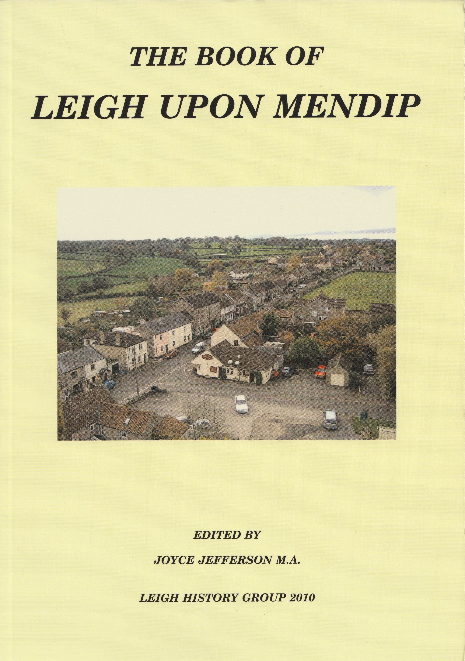

The Book of Leigh Upon Mendip

Joyce Jefferson (ed) £10.00.

151 pages 2010

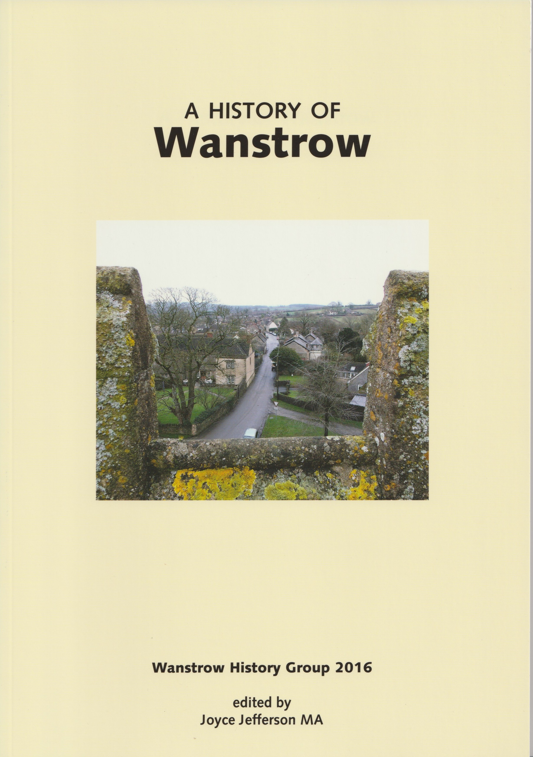
A History of Wanstrow

Joyce Jefferson (ed) £10.00

103 pages 2016

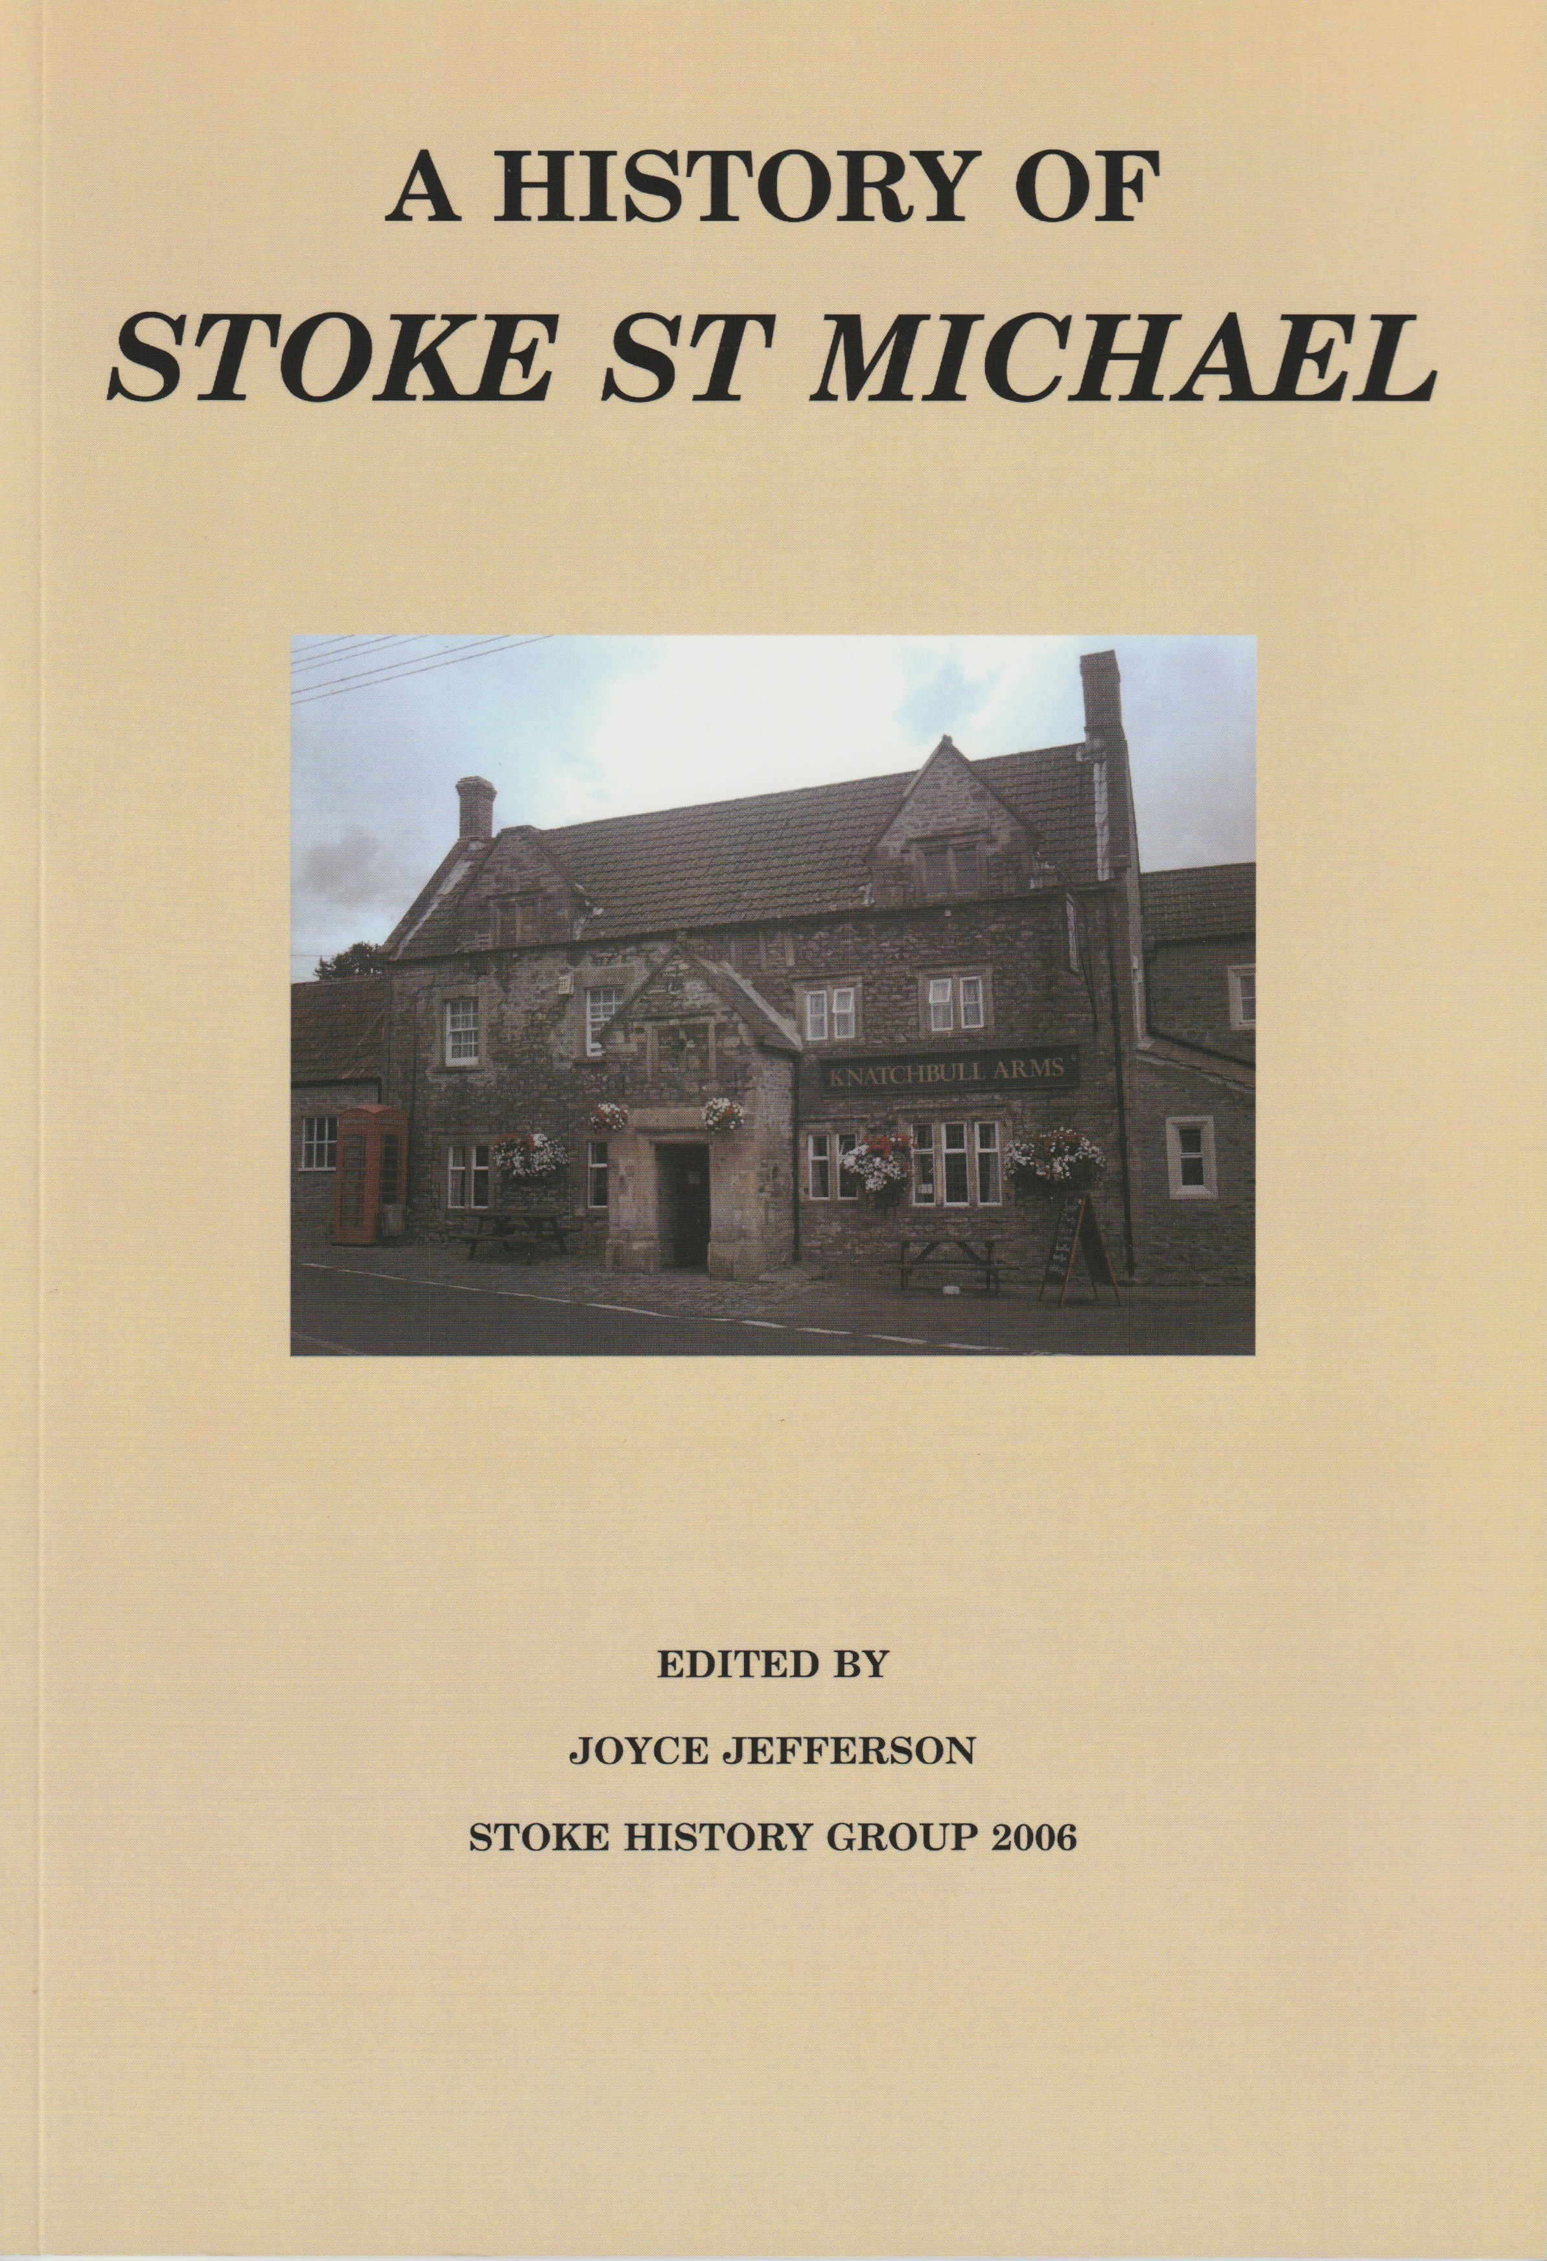
A History of Stoke St Michael

Joyce Jefferson (ed) £8.50

89 pages 2006

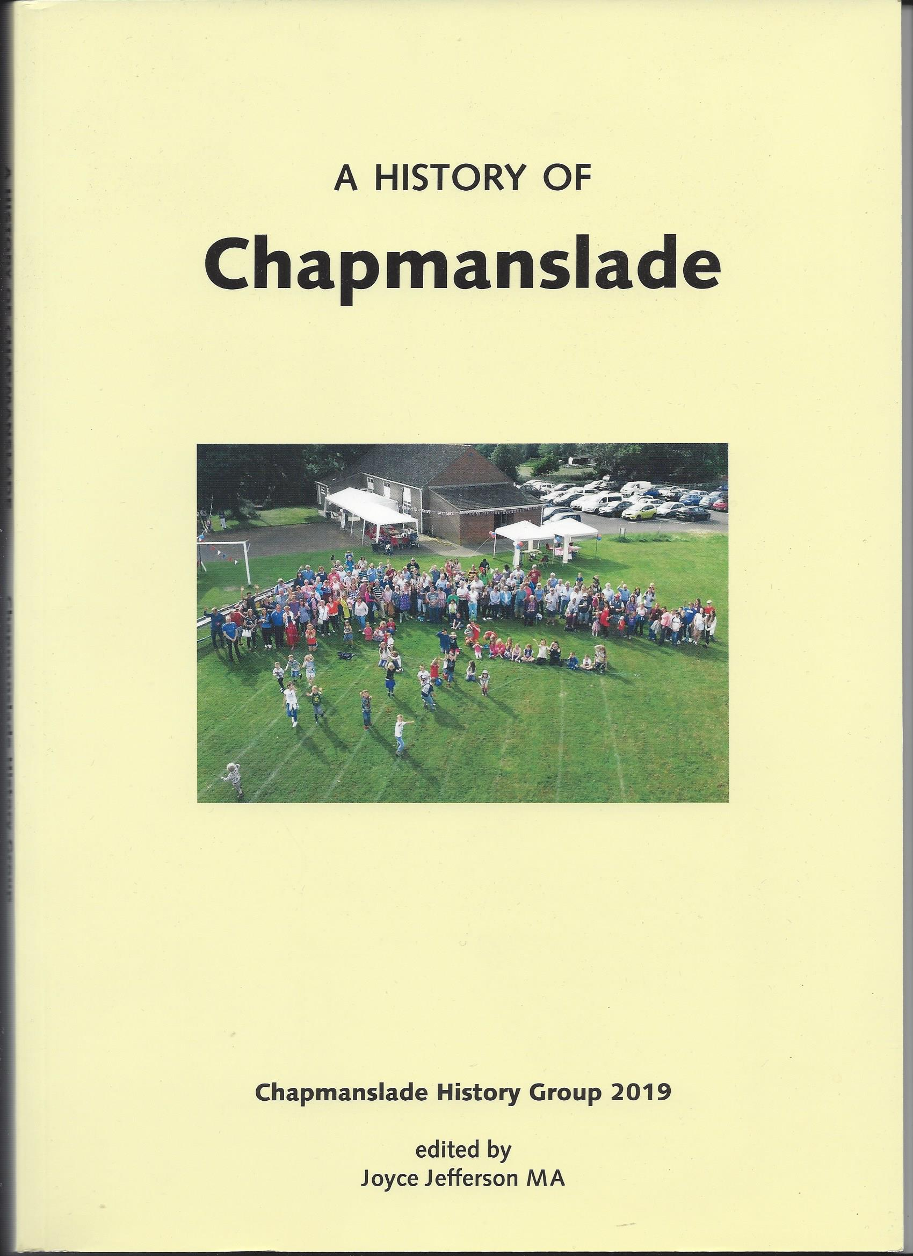

A History of Chapmanslade

Joyce Jefferson (ed) £10

102 pages 2019

