FICTION BASED IN AND AROUND FROME

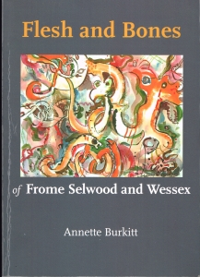
Flesh & Bones of Frome Selwood & Wessex
by Annette Burkitt £12.95
This fictional story is set in AD 934 when the winter court of King Athelstan of Wessex is taking place in Frome. The church of John the Baptist and the royal palace are where the story of jealousy and intrigue take place. This novel is based on original documents and recent historical research.
388 pages. ISBN 9781906798501

The Gorge
by Annette Burkitt £12.95
Historical novel set in Somerset and Dorset in the 10th century, sequel to the author's Flesh and Bones (2017). King Athelstan is dead. Long live the new king, Edmund, his half-brother. The cobbled-together nation of England must react to the challenges of the times: threats from Northumbria and Ireland, resentment from Mercia, pressure from a Church flexing its powerful Catholic muscles. Reformation is in the air. The House of Wessex is weakened by a cliff-top promise and suffers a shocking assassination. Was it intended or was it provoked?

382 pages ISBN 978-1914407185

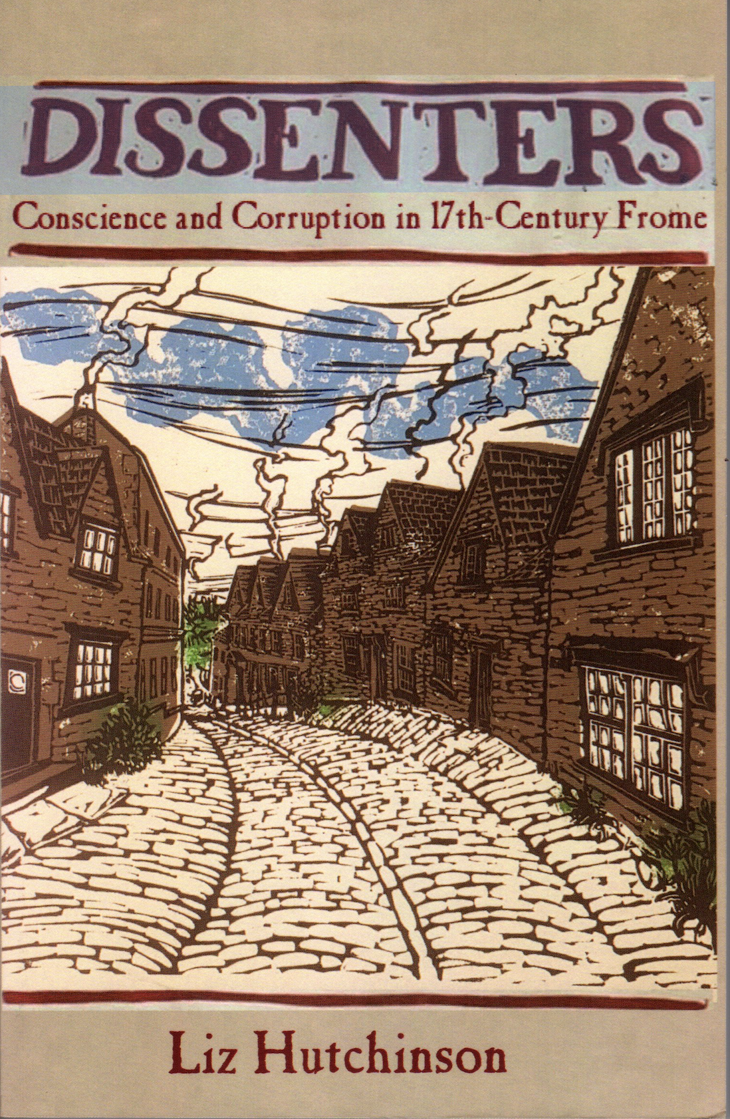
Dissenters
by Liz Hutchinson £10.95
The novel is set in the 1660s and describes the life of a sister and her two brothers from Frome who become members of a smuggling gang. This takes place against a background of the flourishing cloth industry and the growth of non-conformism and the expansion of the town.
276 pages. ISBN 9781906978839

