BOOKS & MAPS: FROME TOWN

This catalogue is divided into four sections, The Town, Surrounding Villages, The work of the Villages History Group and a small fiction section. There are a number of pamphlets long out of print now downloadable in PDF format without charge and available via 'Search Our Collection' at www.frome-heritage-museum.org
Current publications are available in person from
Frome Museum 1, North Parade, Frome BA11 1AT 01373 454 661
Winstone's 10 Cheap Street, Frome BA11 1BD 01373 473 111 winstonebooks3@gmail.com
Wholesale rates on request from the Frome Society at publications@fsls.org.uk
Postage is charged extra at cost but free delivery within the town where possible.

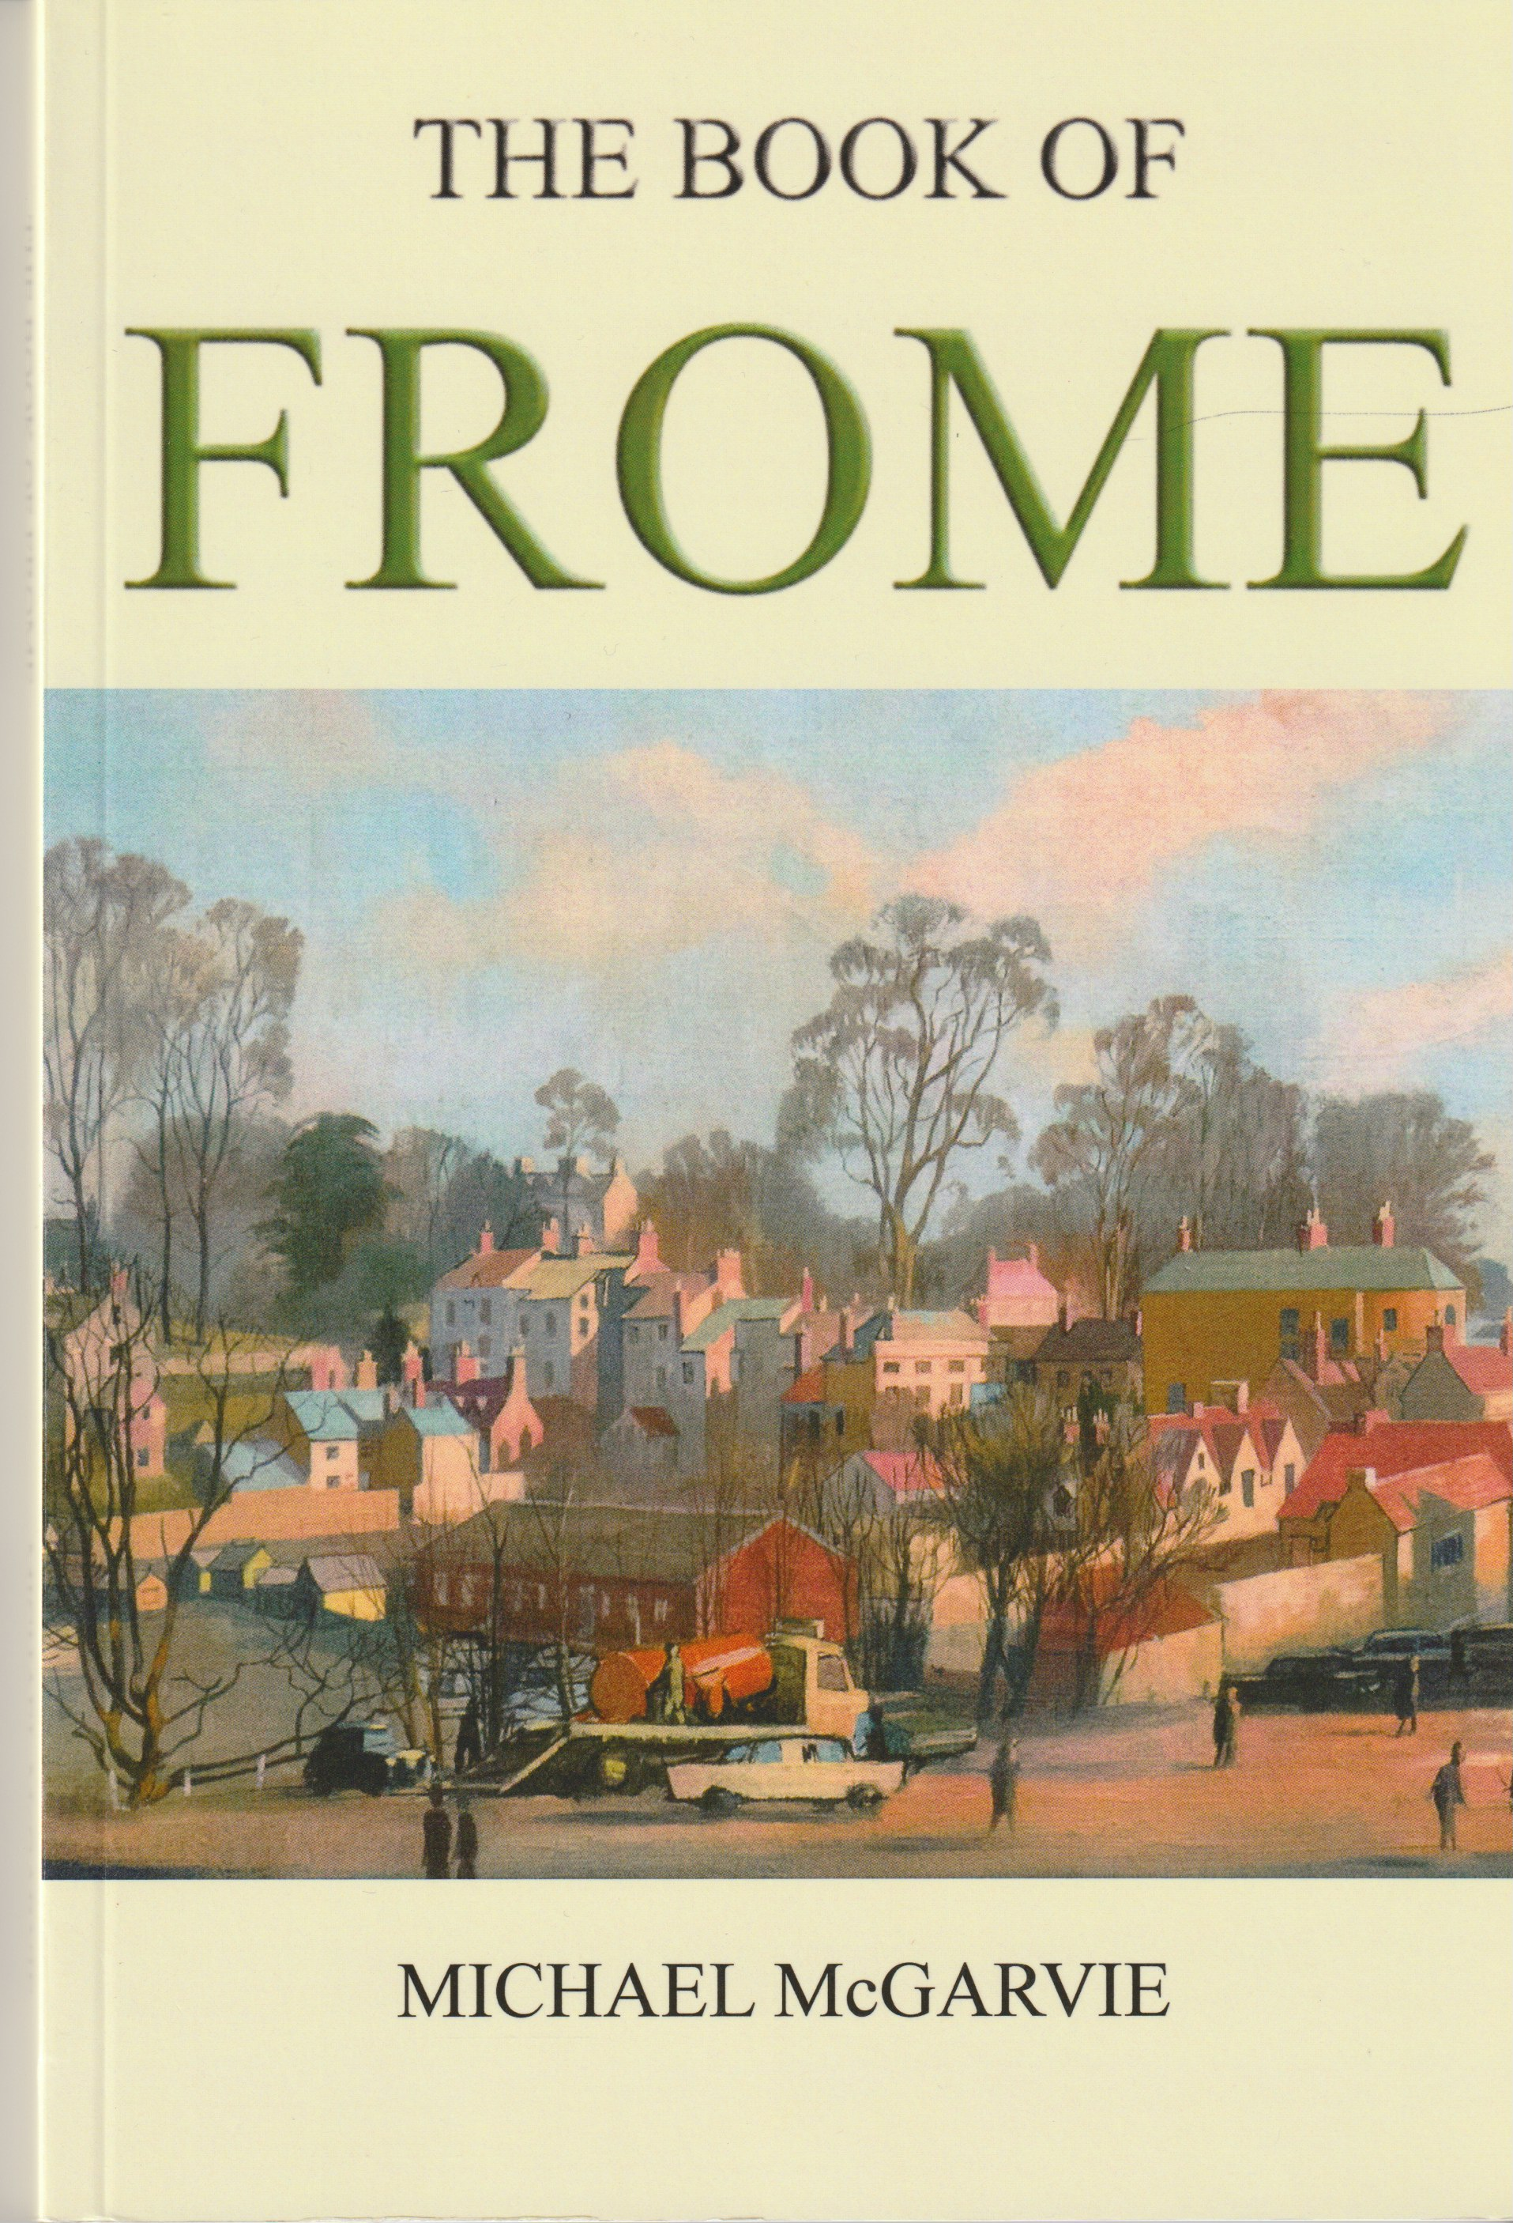

The Book of Frome

(5th ed) by Michael McGarvie £15.00
Michael McGarvie, Frome’s foremost historian, has written the definitive history of Frome and describes the development of the town from its foundation in around 685 until 2000. There are chapters on all aspects of the town from its origin to the present day. It is fully illustrated and has many rare photographs, drawings and maps.

163 pages. ISBN 978-0-9565-8697-1

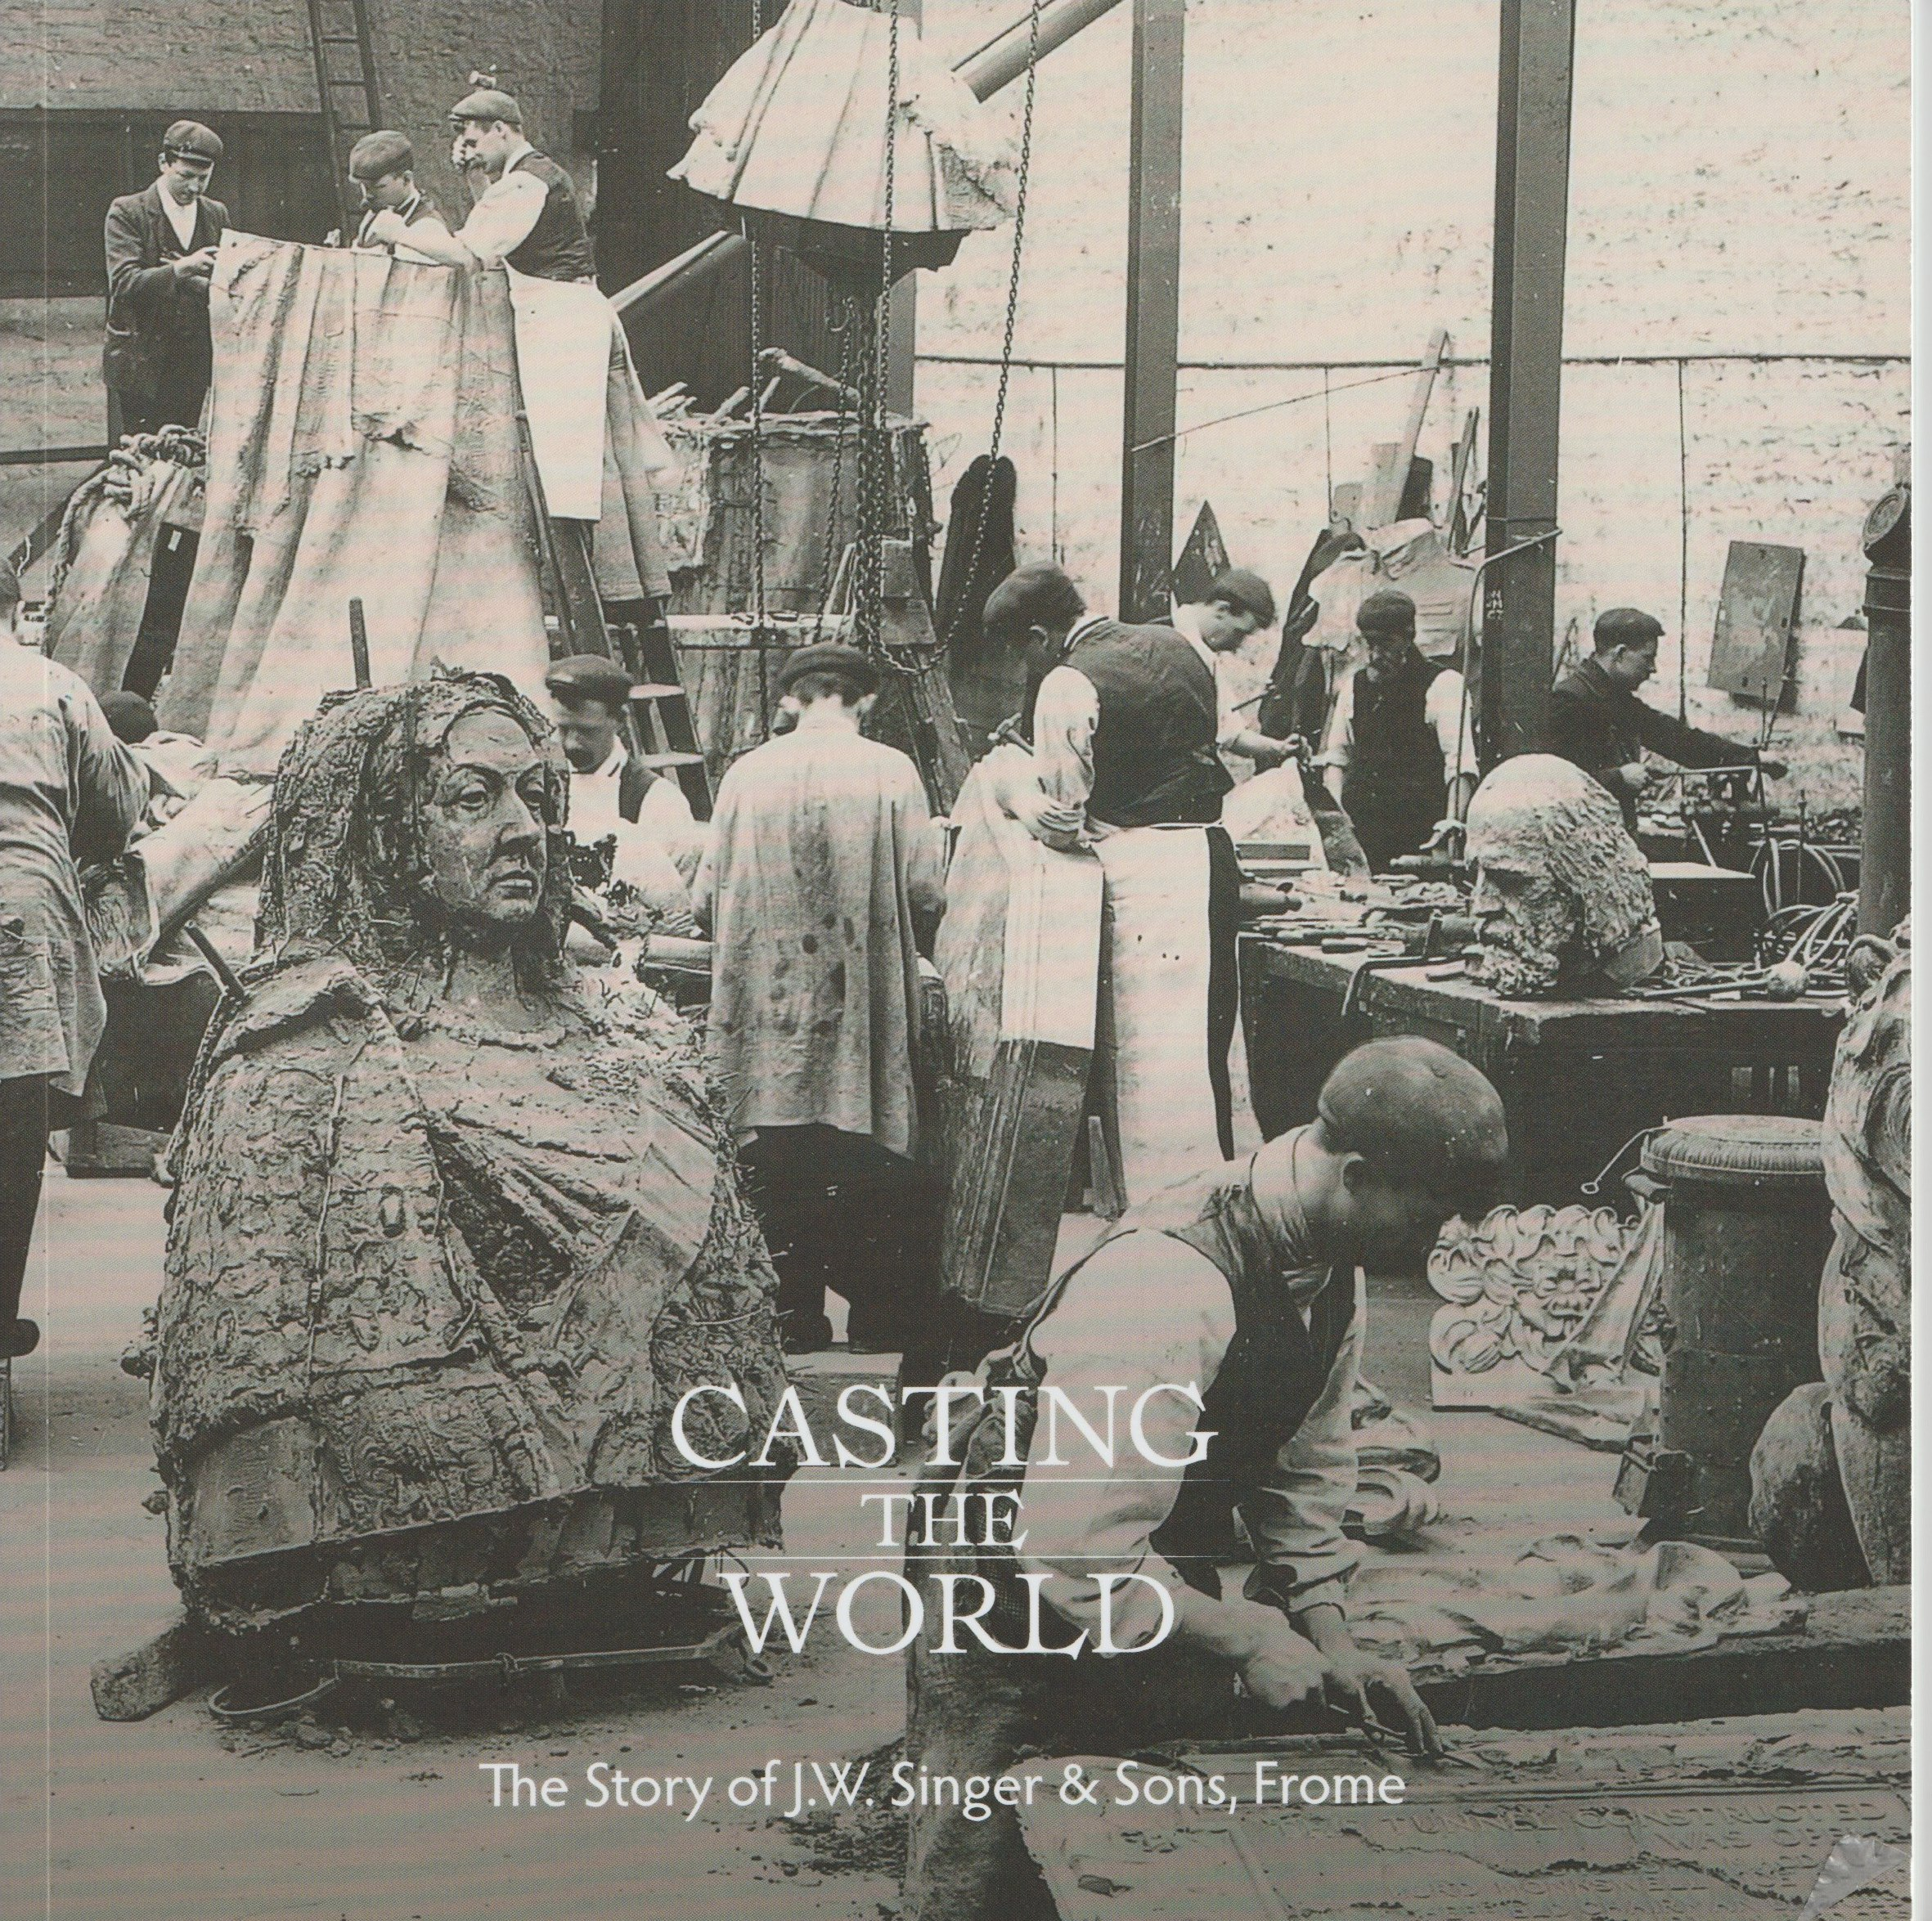
Casting the World

by Sue Bucklow £10.00

The story of JW Singer & Sons metal founders from its foundation in 1848 until it finally closed in 1956 with many contemporary photographs of the processes and the final location of its many famous statues throughout the world. 80 pages
ISBN 978-1-5272-4118-3

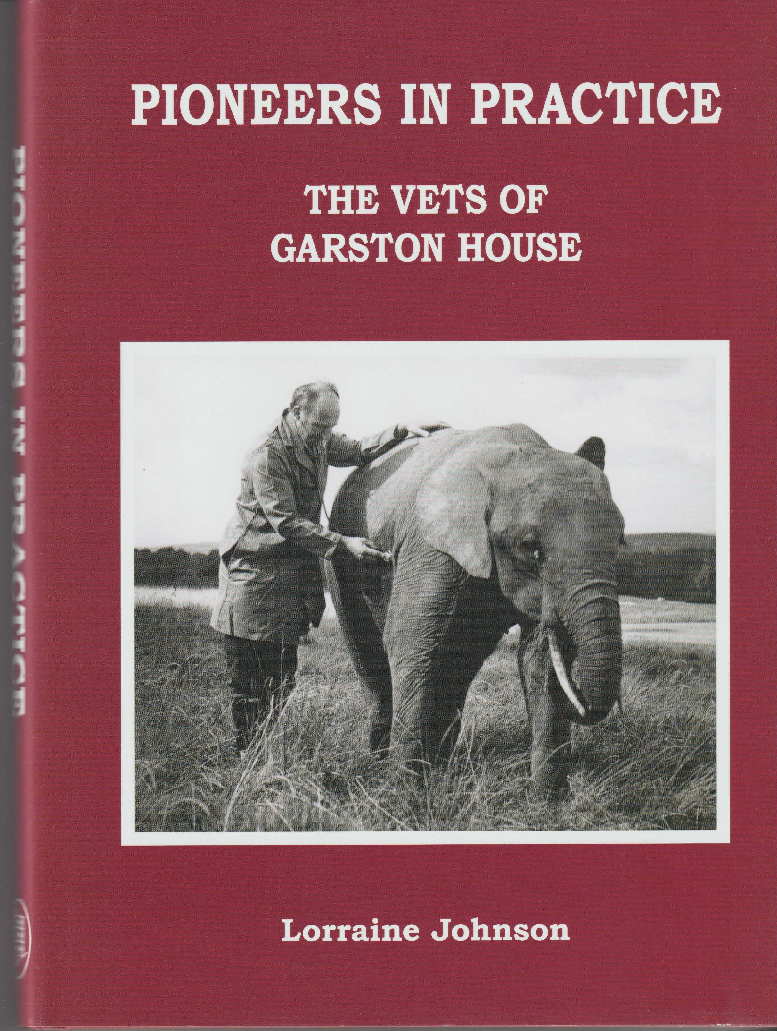

Pioneers in Practice

by Dr Lorraine Johnson £18.00

The vets of Garston House, their history and practice over almost 100 years from small beginnings to their innovative research and study of early vaccines and their ground - breaking work caring for the animals at Longleat Safari Park

178 pages HB ISBN 978-0-9568136-6-4

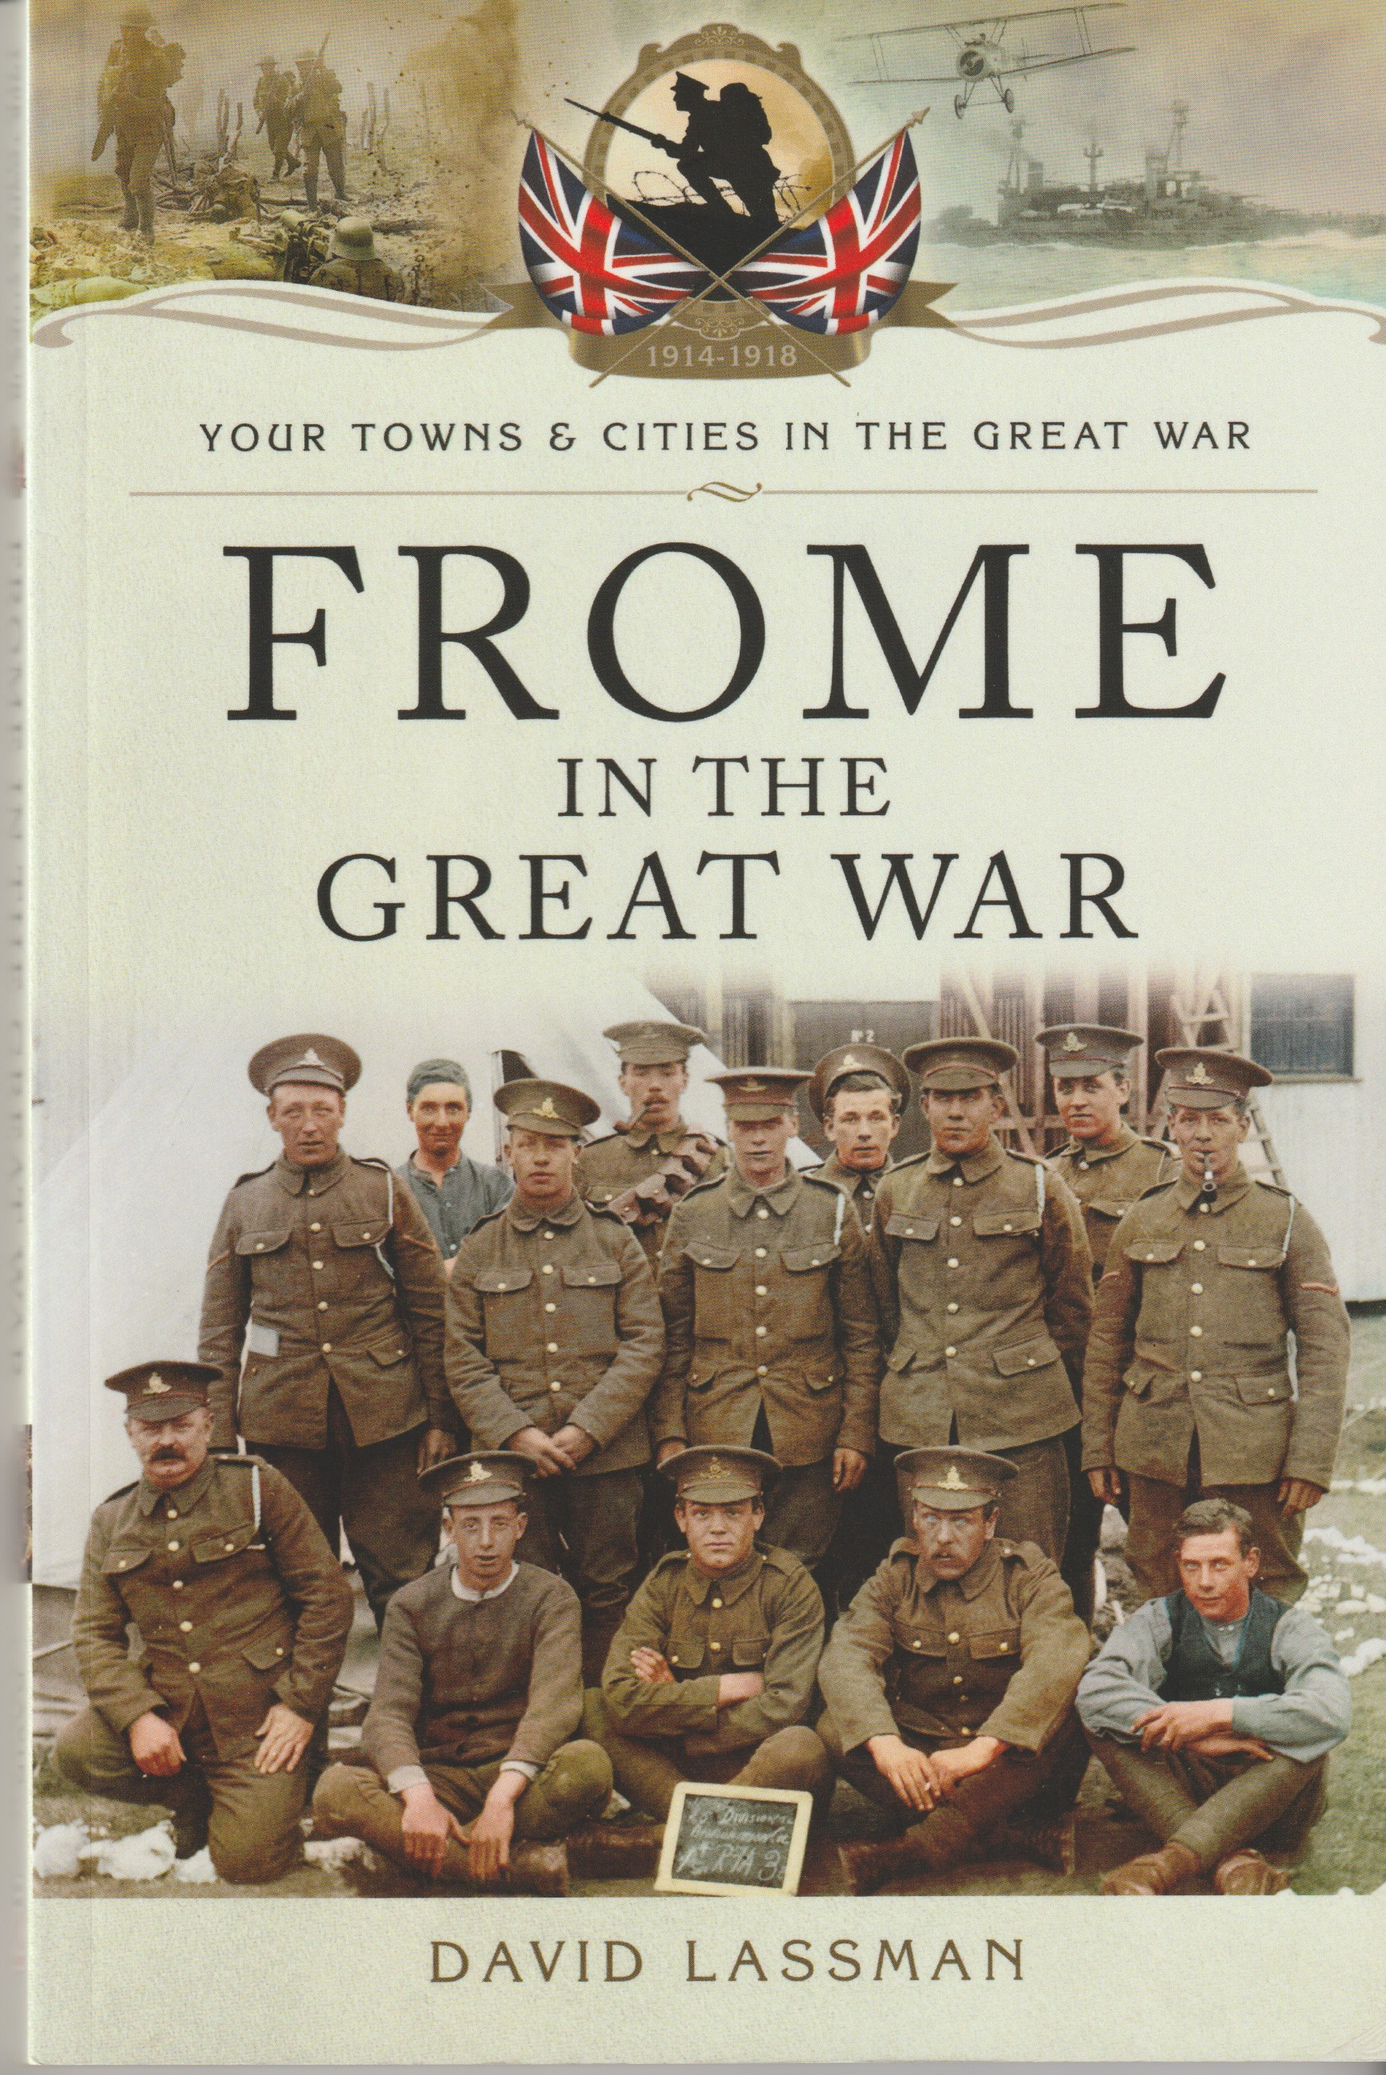

Frome in the Great War

by David Lassman £12.99

The First World War comes to Frome. Local men experienced action in all the theatres of war that the global conflict encompassed, taking part in numerous battles and campaigns on land and sea; its civilian population received a special commendation after the war for its efforts throughout.

106 pages. ISBN 978-1-47383-593-1

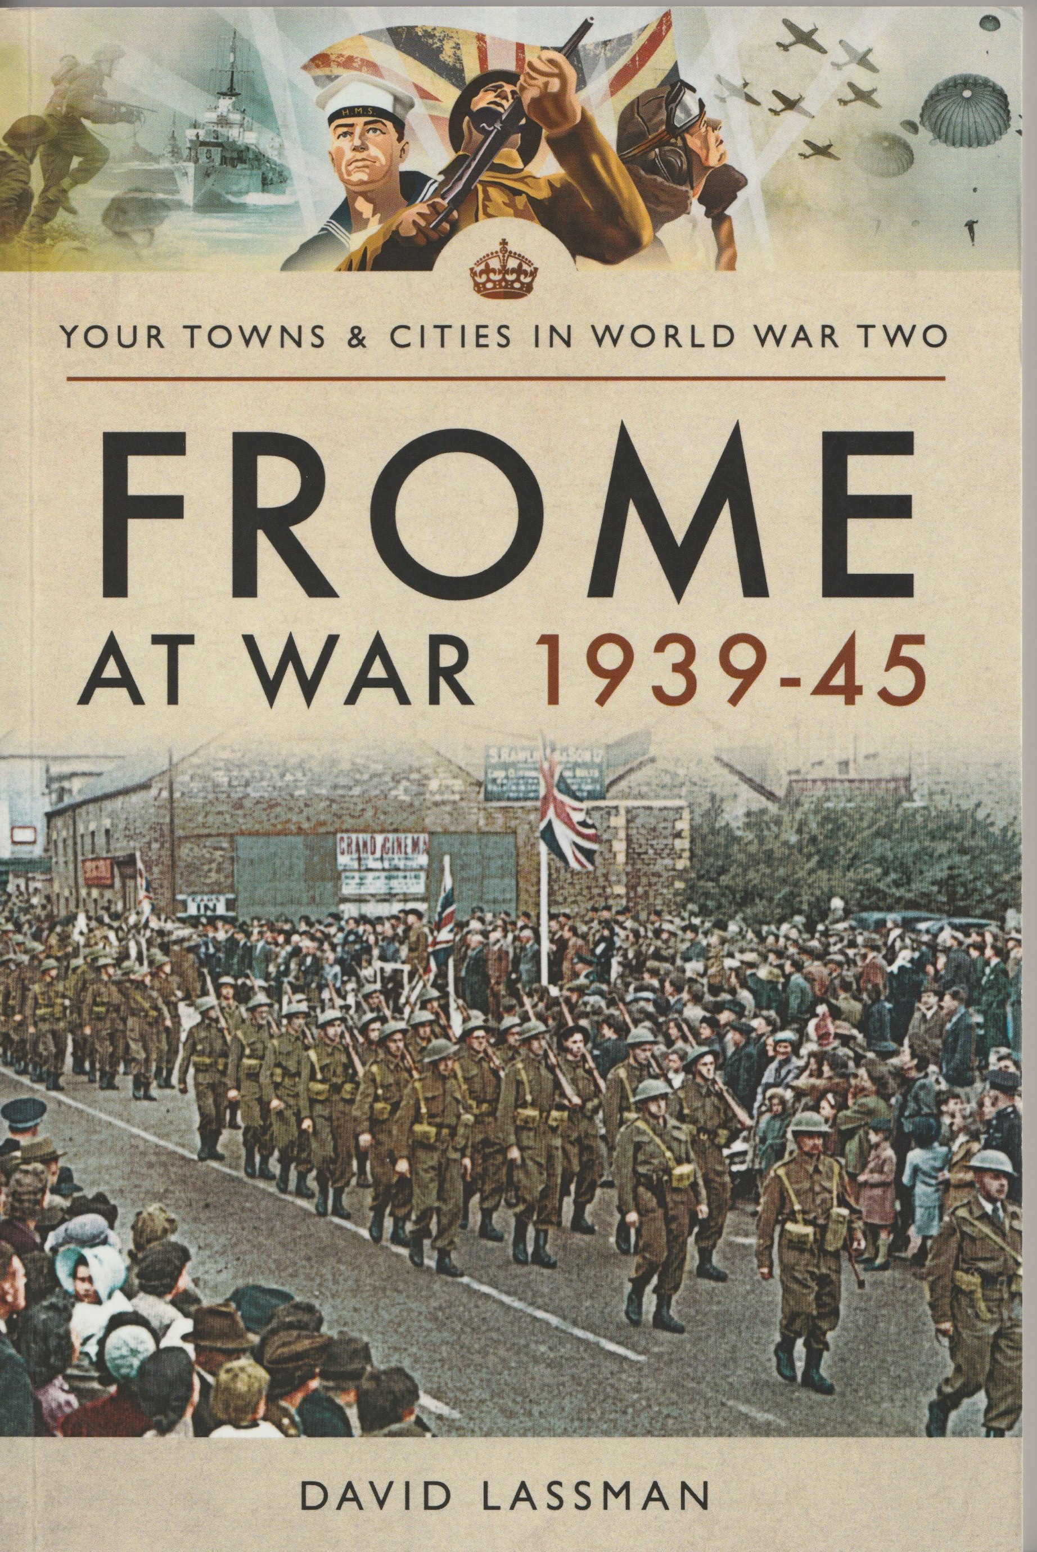
Frome at War 1939-1945

by David Lassman £14.99

A comprehensive account of the Frome's war years giving rare insights into the life of the town including its part in the secret underground resistance movement, the influx of GIs and tales of endurance and courage.

222 pages. ISBN 978-1-52670-6-003

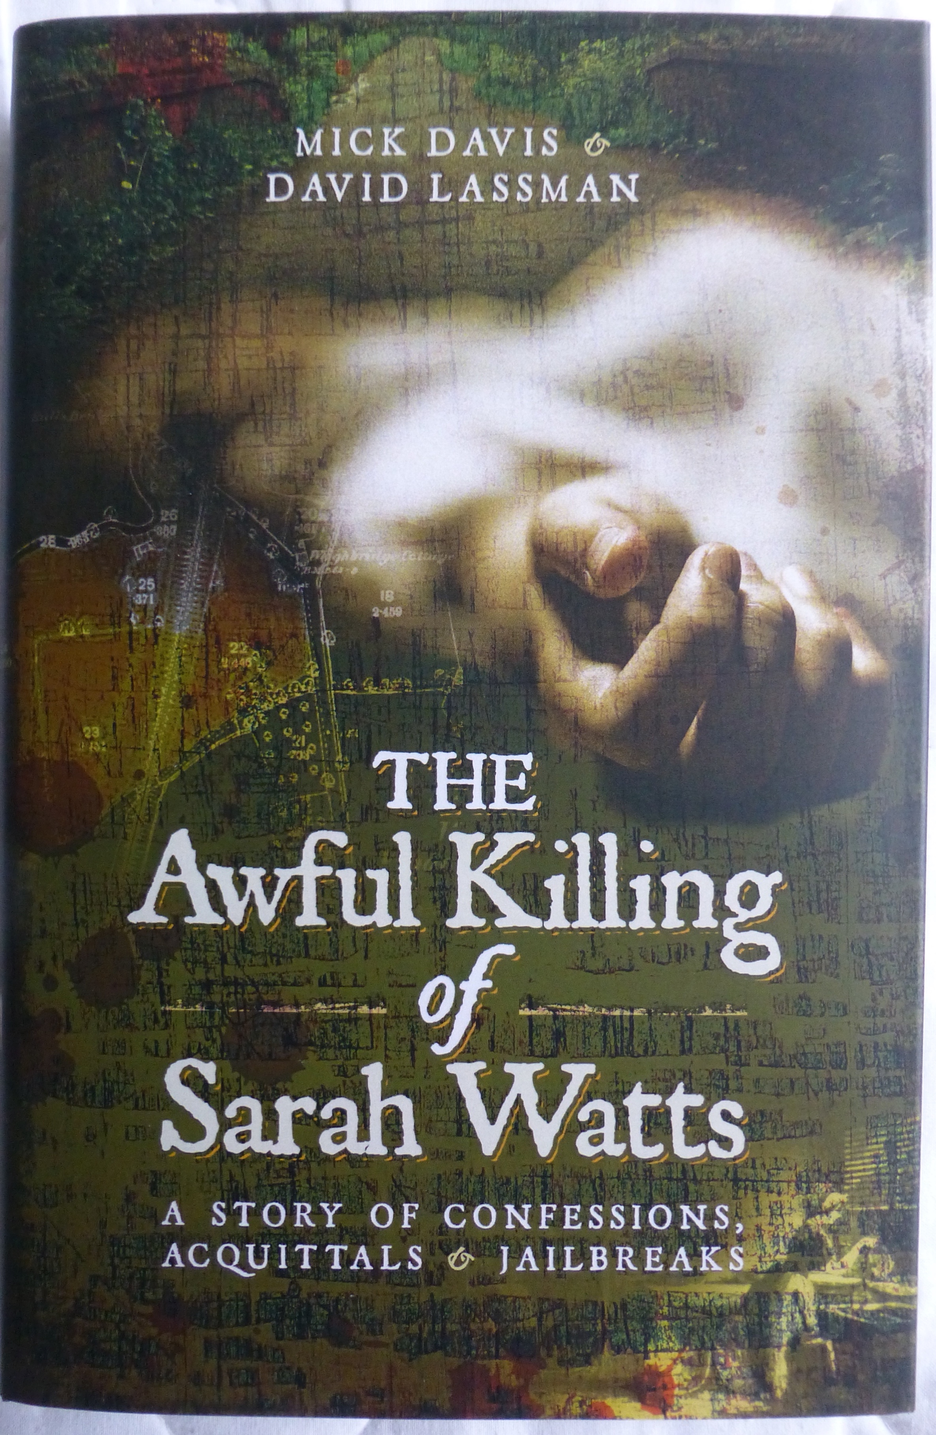

The Awful Killing of Sarah Watts

by Mick Davis & David Lassman £12.00

The fascinating story of Frome's unsolved murder from 1851. Sarah Watts was raped and murdered while her parents were out at the market. Despite intense enquiries and the trial of four suspects there were no convictions. A detailed examination of the Town's Victorian underworld. Hardback

257 pages ISBN 978-1-52670-730-7

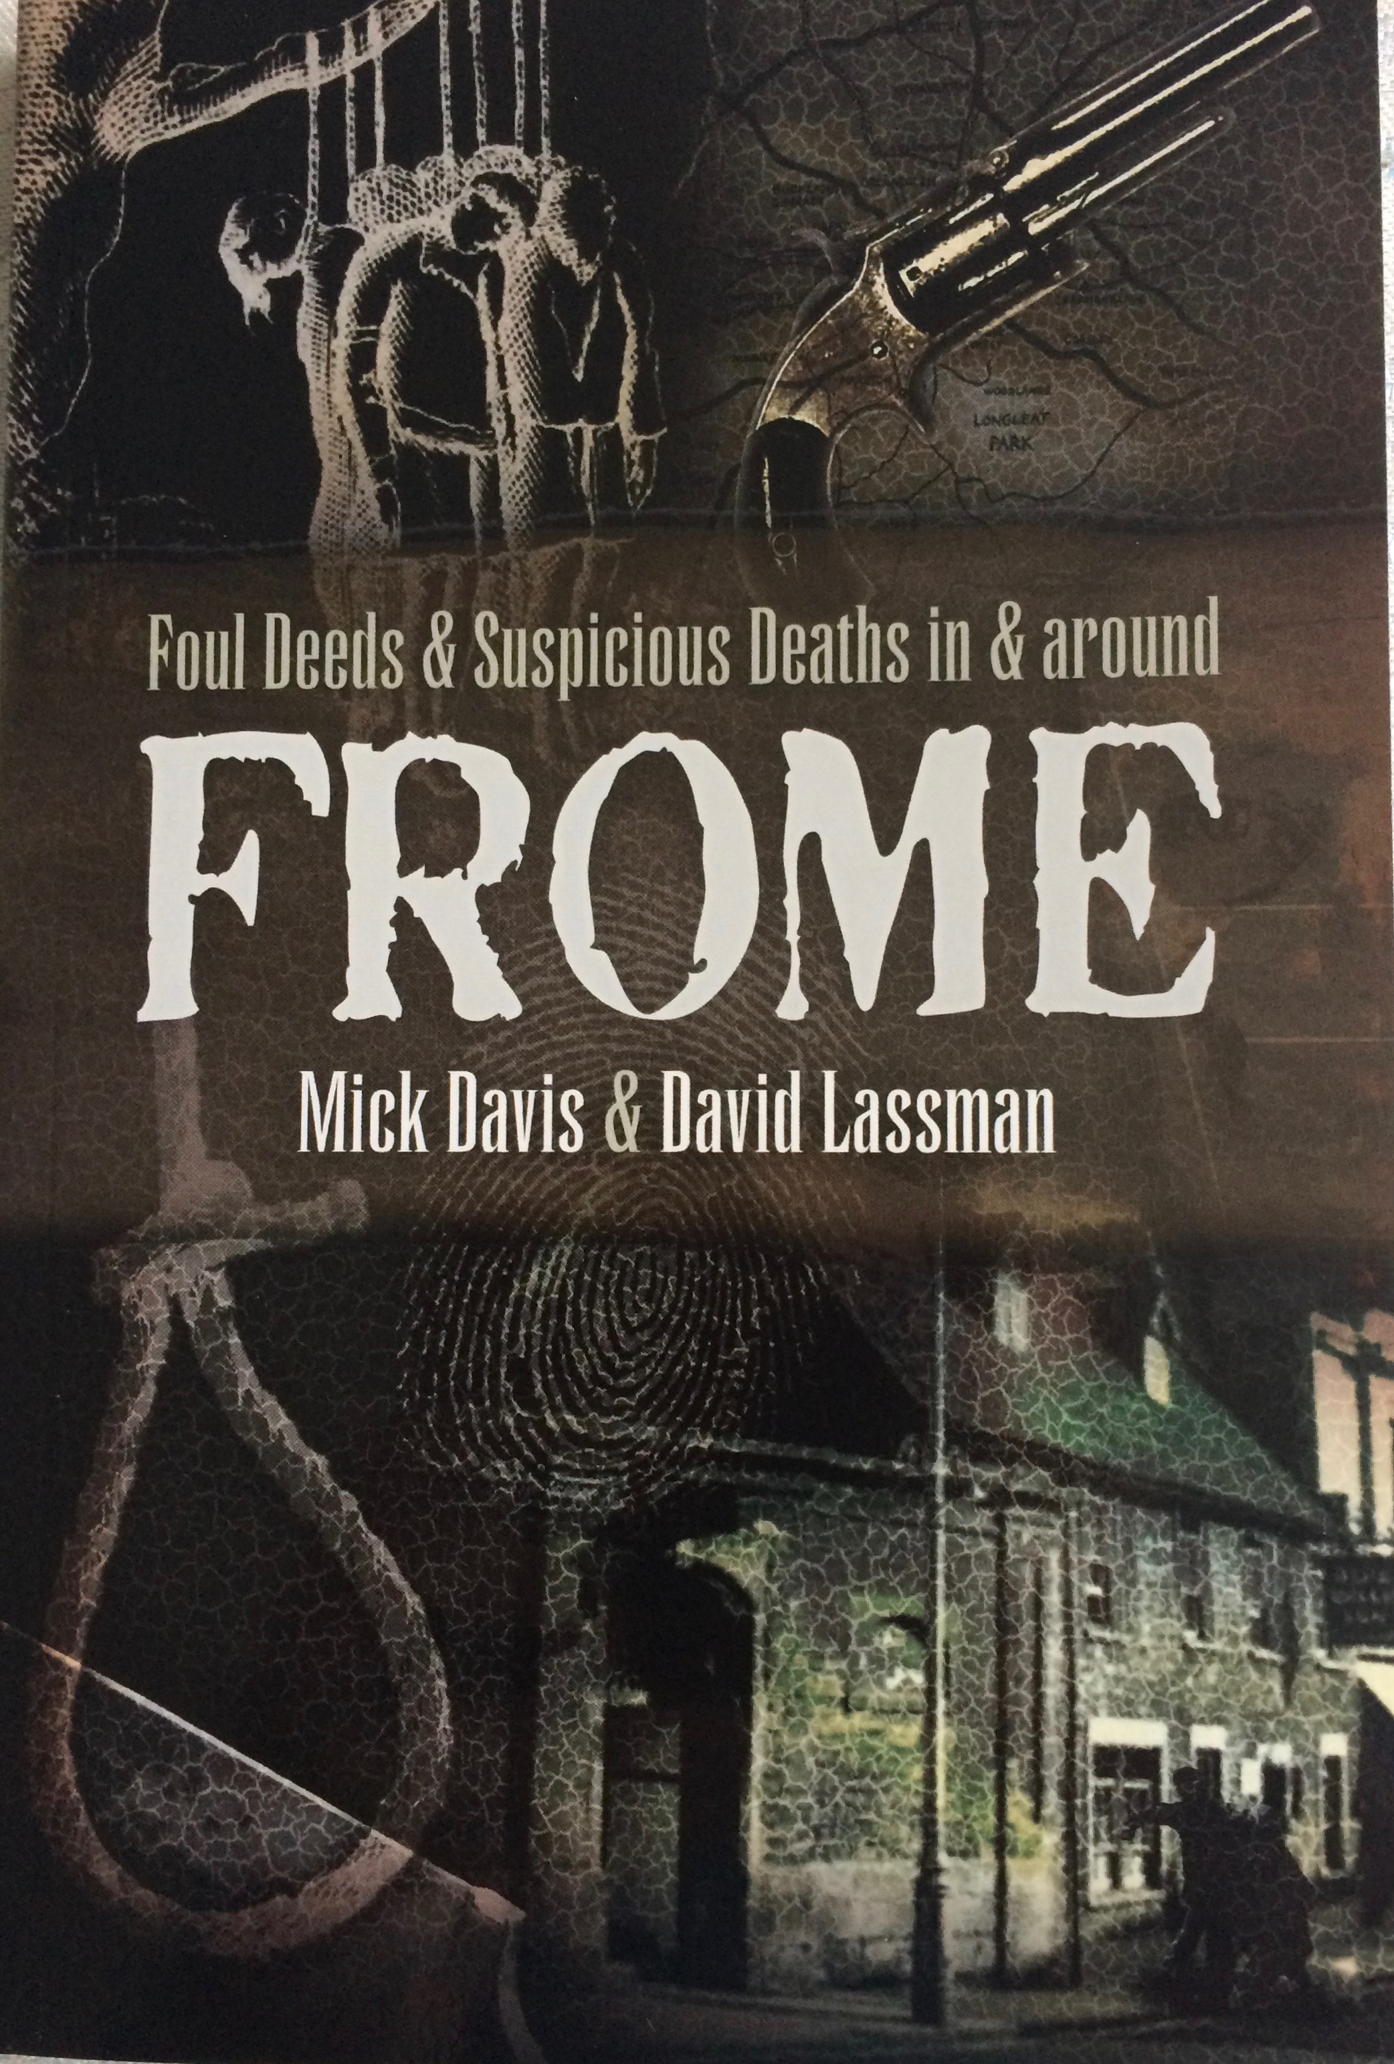

Foul Deeds & Suspicious Deaths in Frome.

by Mick Davis & David Lassman £10.00

14 cases from Frome's criminal history including witchcraft, highwayman, murder and madness, suicide and fraud. A cornucopia of criminal delights fully illustrated.

129 pages ISBN 978-1-52670-604-1

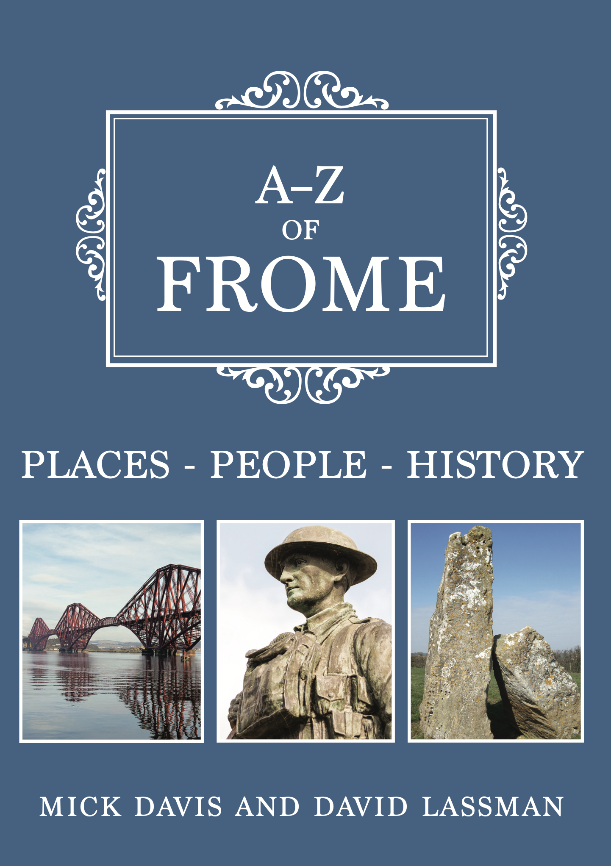
A-Z of Frome

by Mick Davis & David Lassman £15.99

Fairly light-hearted look at the town's finest features and quirky stories from a dancing bear, some prehistoric stones, flying saucers and a unicorn with many colour photographs.

96 pages ISBN 978-1-3891-0346-7

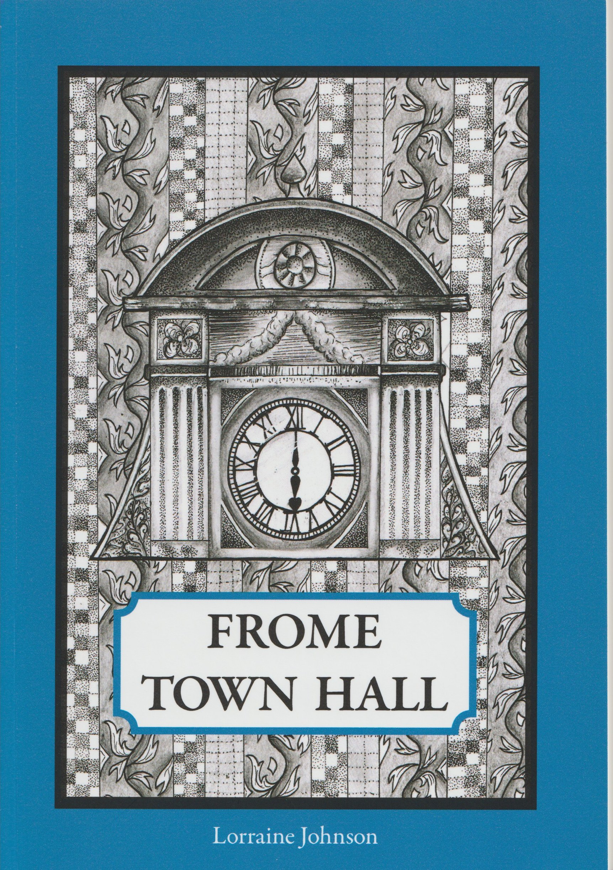

Frome Town Hall

by Dr Lorraine Johnson £7.50

A history of the towns administrative centre completed in 1892. It has housed a host of characters throughout its long history and this is the story of how and why it was built and the story of those who worked there with many illustrations.

111 pages ISBN 978-0-9568136-3-3

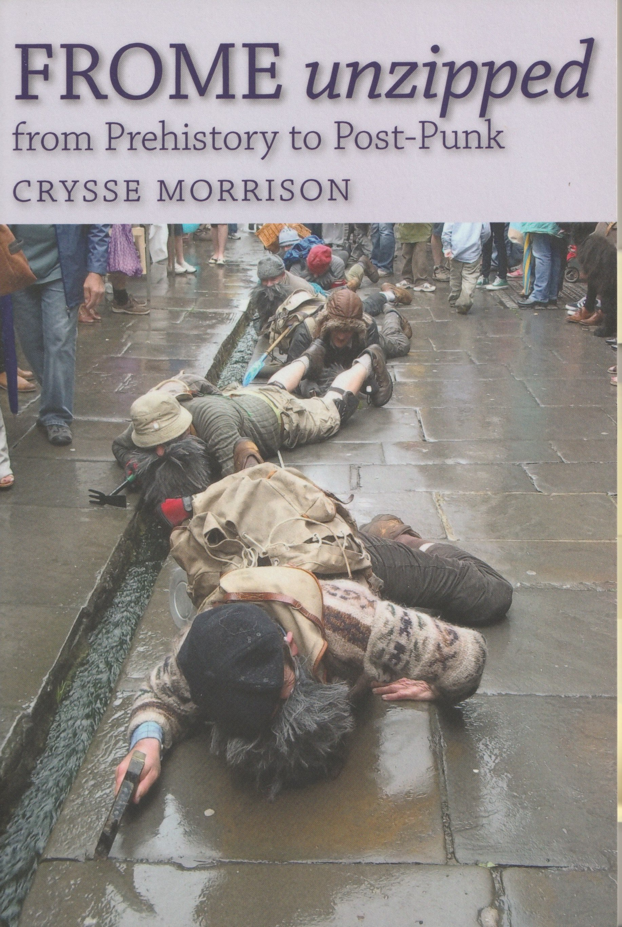

Frome Unzipped

by Crysse Morrison £12.50

A look at Frome in all its many guises from Prehistory to Post Punk and embracing its independence of spirit. A fascinating book full of fun and frolic, witty, learned, and very well researched. A great read.

240 pages ISBN 978-1-906978-55-6

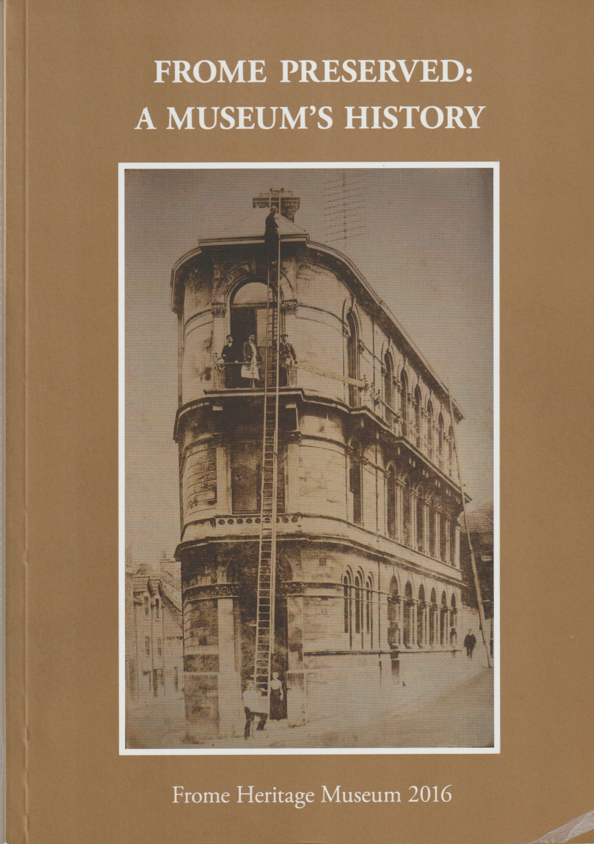

Frome Preserved

by Dr David Robinson £12.00

The early history of Frome Museum and the Frome Society from its foundation in 1958 and taking the story up to 2016.

185 pages ISBN 978-0-9568136-1-2

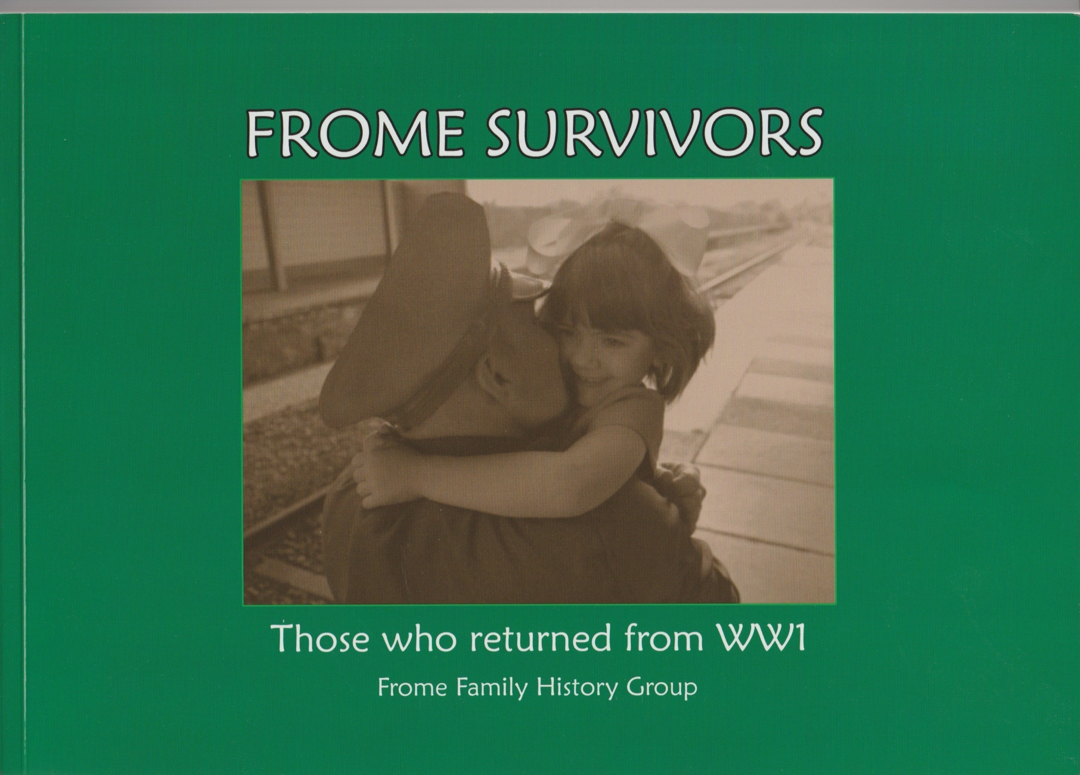
Frome Survivors

Frome Family History Group £10.00

The story and service records of over 140 men who returned from the First World War including photographs of them and their homes where possible an excellent and in-depth piece of research.

152 pages ISBN 978-1-5262-0775-3

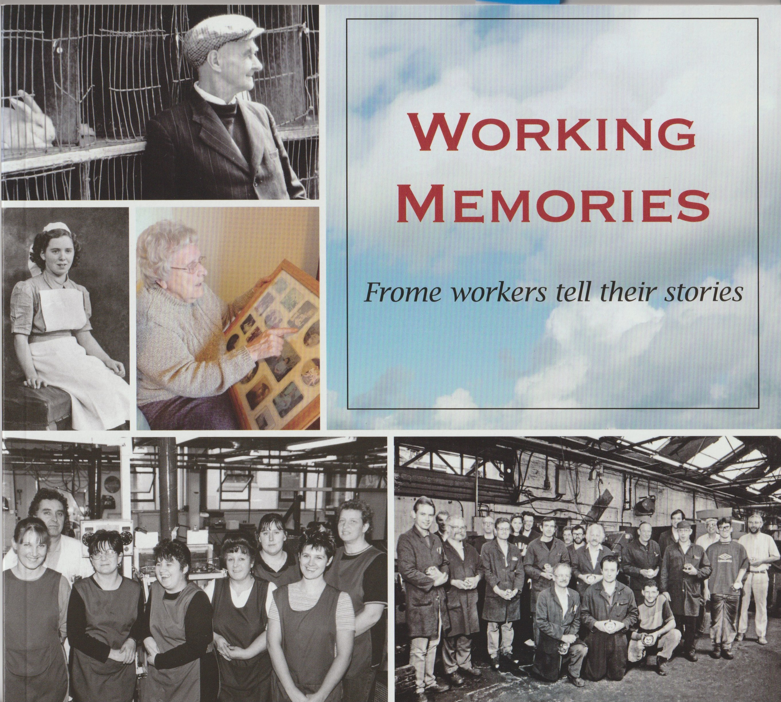

Working Memories

John Payne (ed) £10.00

Frome people tell the story of their working lives, many illustrations and fascinating tales.

144 pages ISBN 978-0-948975-99-8

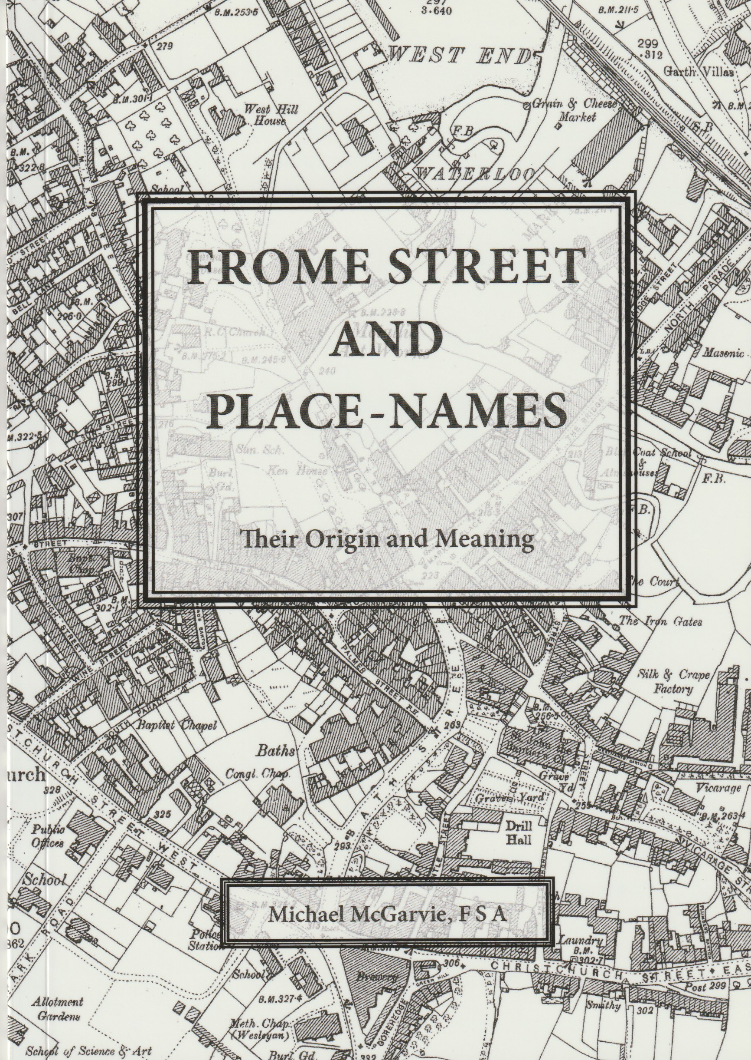

Frome Street and Place Names

(4th ed) by Michael McGarvie £6.00
An erudite and entertaining description of the derivation of the place and street names in Frome. Many of these date from the middle ages or recall the names of householders who lived in the street. recently reprinted.

52 pages. ISBN 978-0-993060540

The Butler & Tanner Story

by Dr Lorraine Johnson £12.00
The development of Butler and Tanner from its foundation by William Langford printing labels for his chemist shop to become the finest colour printer in the country. The trials and tribulations of operation in wartime are covered, together with the slow decline of the company which ended in closure in 2014. There are descriptions of many of the leading characters. The book is superbly illustrated.

133 pages. ISBN 9780993060502

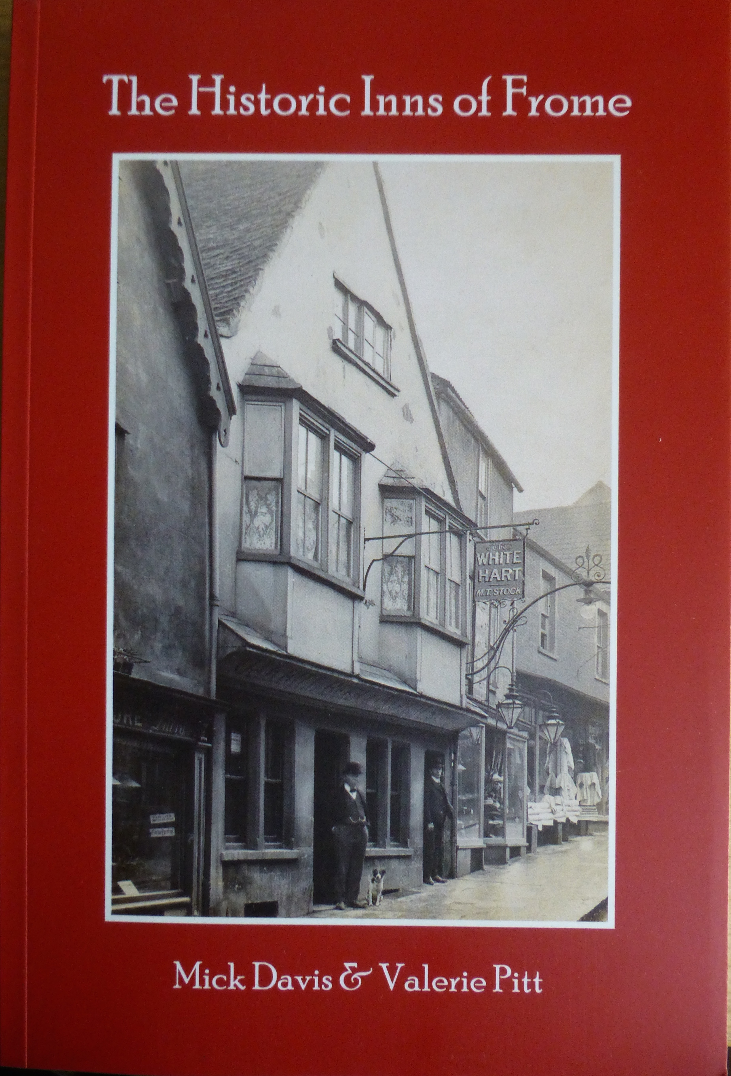

The Historic Inns of Frome

by Mick Davis & Valerie Pitt £10.00
The history of Frome's pubs past & present starting with the long-lost Albion in Cheap Street via the ancient Blue Boar the magical Crooked Fish and the elusive Wyredrawers Arms. An undoubted a classic of the genre now reprinted for the third time.

180 pages ISBN 978-0-9560989-9-3

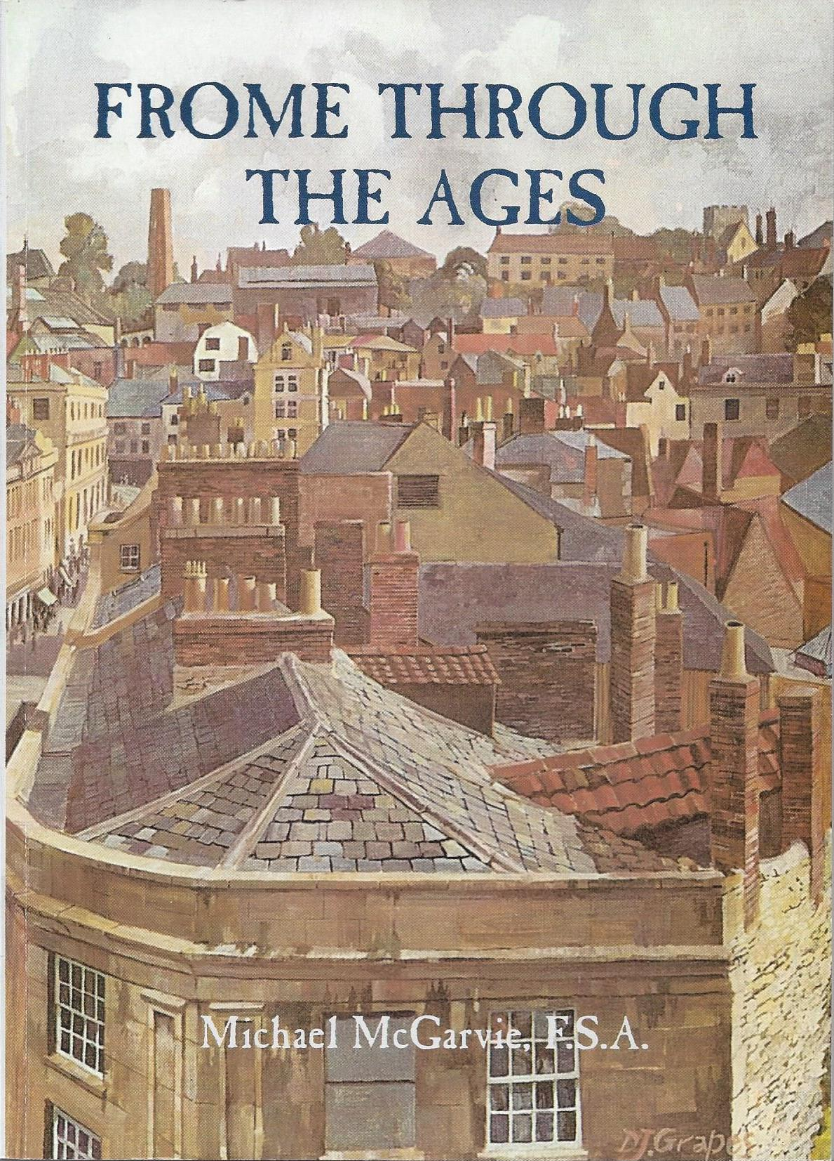

Frome Through the Ages

(2nd ed) by Michael McGarvie. £5.00

Michael McGarvie has compiled an anthology of nearly 150 extracts and descriptions relevant to Frome which were published to coincide with the celebration of the town’s 1300th anniversary in 1985, with many original photographs.

176 pages. ISBN 978-0-948014284

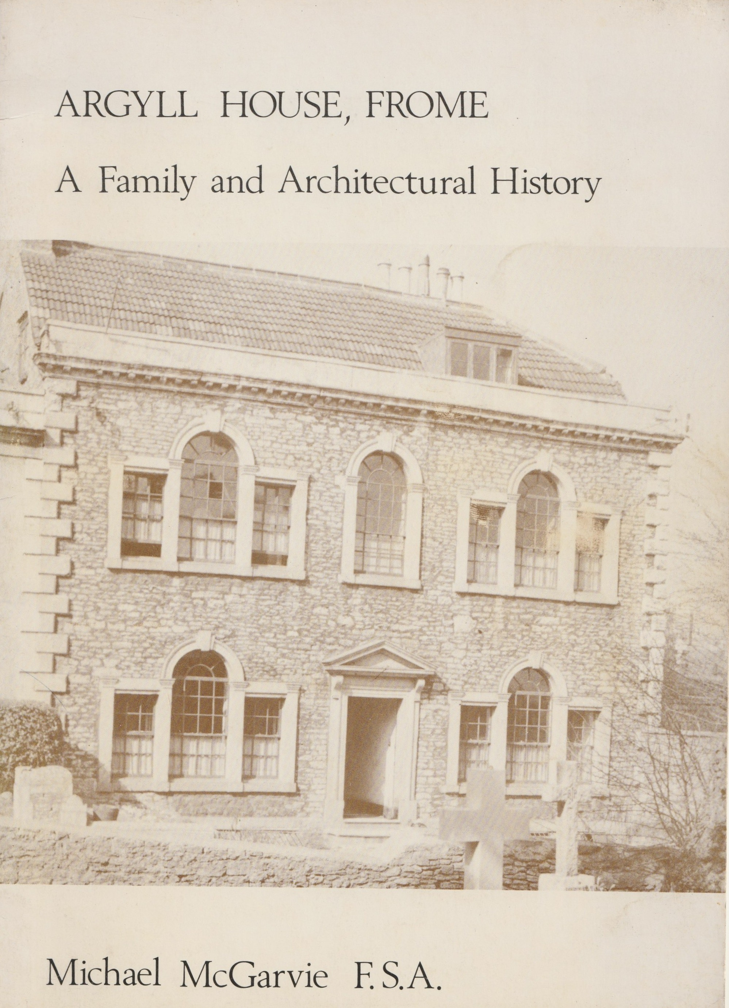

Argyll House Frome

by Michael McGarvie £3.00

A history of the house in Gentle Street from its mediaeval origins to the present building of around 1770 from gentleman's house to temporary public house and back again.

29 pages.

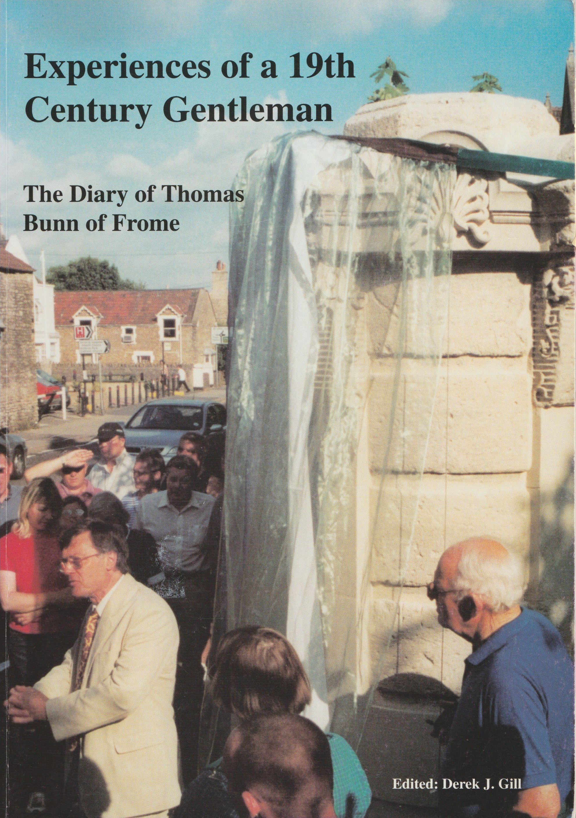
Experiences of a 19th Century Gentleman

by Derek Gill (ed) £10.00

The extensive diary of Thomas Bunn, Frome philanthropist who lived from 1767-1853 and initiated many improvements to the town. His diaries range from 1836-1852 and are an absolute mine of information about the town and its characters.

196 pages.

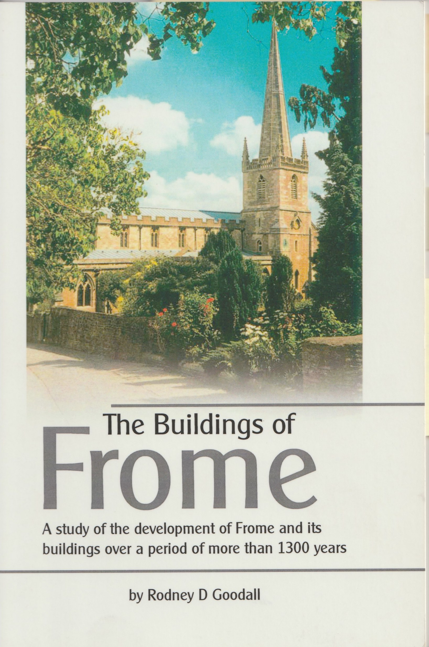

The Buildings of Frome

(3rd ed) by Rodney Goodall £9.00
Rodney Goodall was an architect in Frome for over 40 years. He uses his specialist knowledge to describe the development of the town with detailed descriptions of Frome’s outstanding collection of buildings from 1500 to 2000AD. He relates the buildings to the economic and social history of the town. Fully illustrated.

150 pages. ISBN 9780-9-56586957

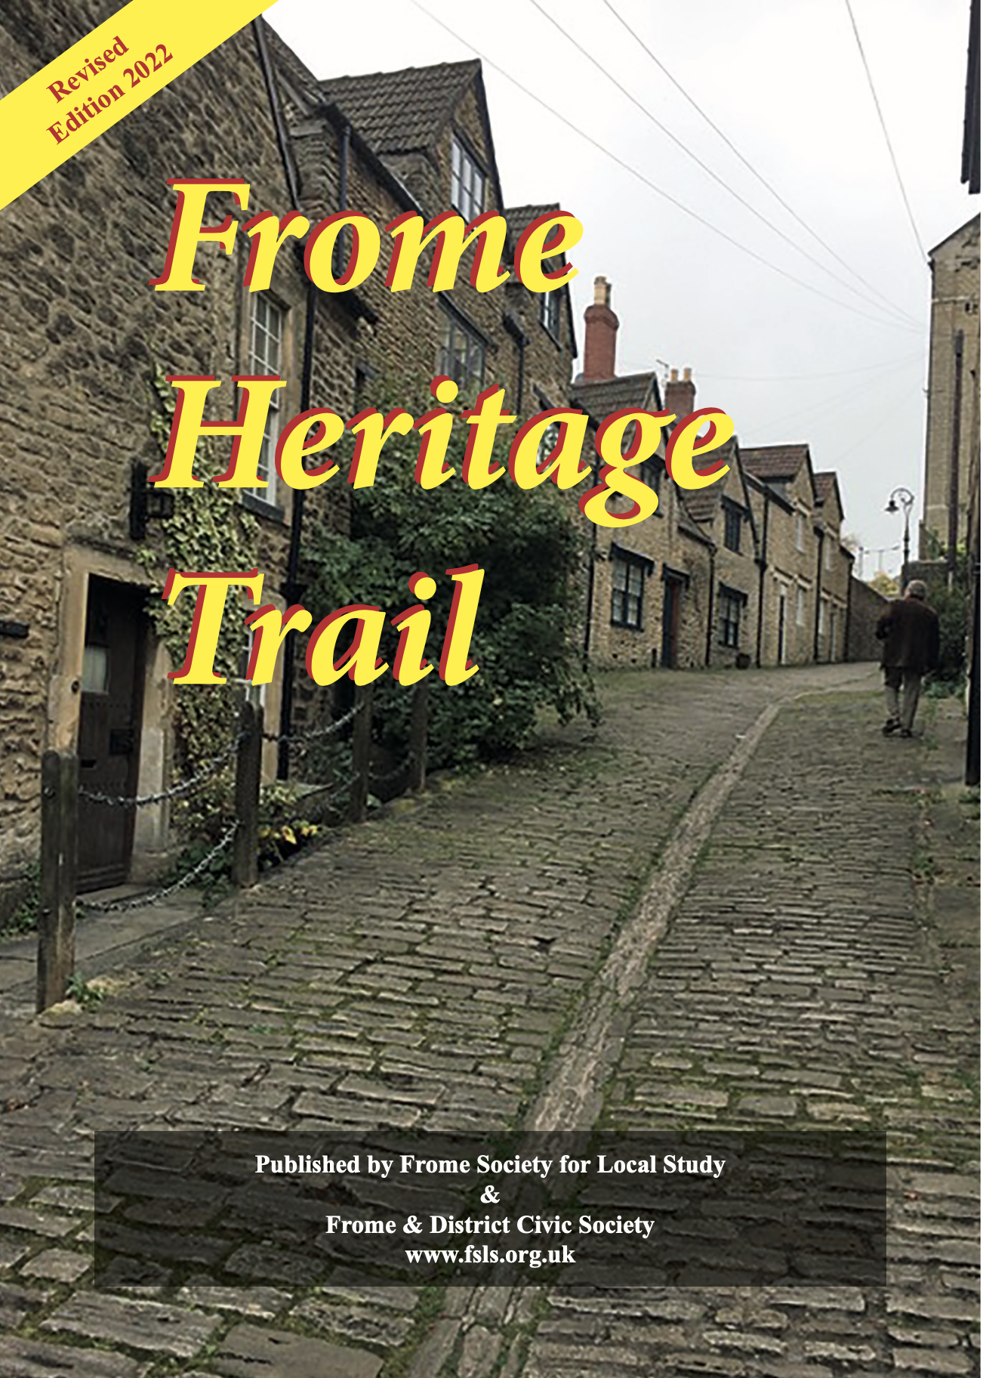
Frome Heritage Trail

revised edition 2022 £3.00

The trail follows a series of plaques which were installed by the Frome-Selwood Building Society to celebrate the 1300th anniversary of the founding of Frome in 685AD. The pamphlet guides the reader through the whole of the old town and describes the important buildings in their historical context. There are many illustrations together with a list of plaques installed by the Frome Society.

16 pages. ISBN 978-0-956586933

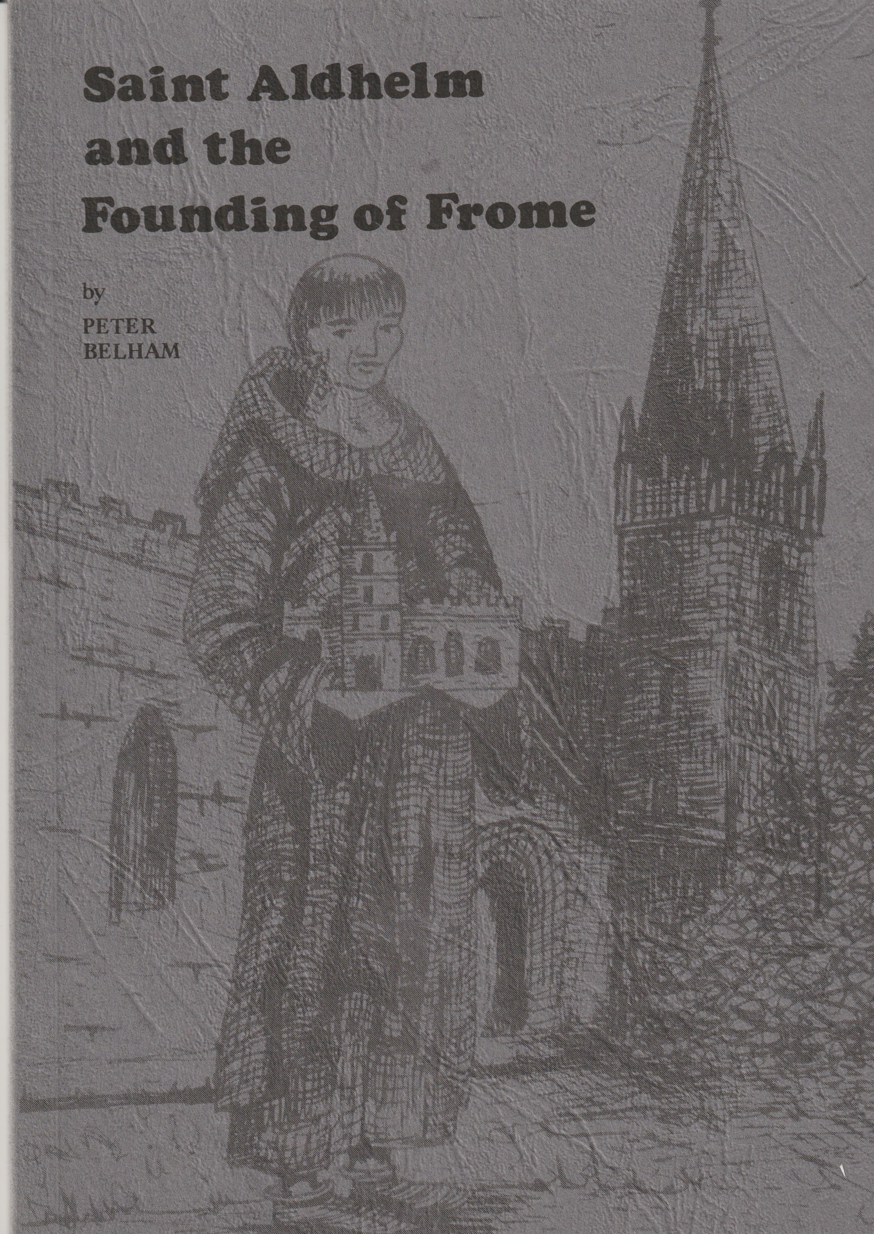

St. Aldhelm & The Founding of Frome

by Peter Belham £2.50

An excellent history of the early years of the town. The author proposes that the church has always been where it is now – and recent excavations strongly support that view. photos. maps & drawings.

49 pages ISBN 0 9510157-2-9

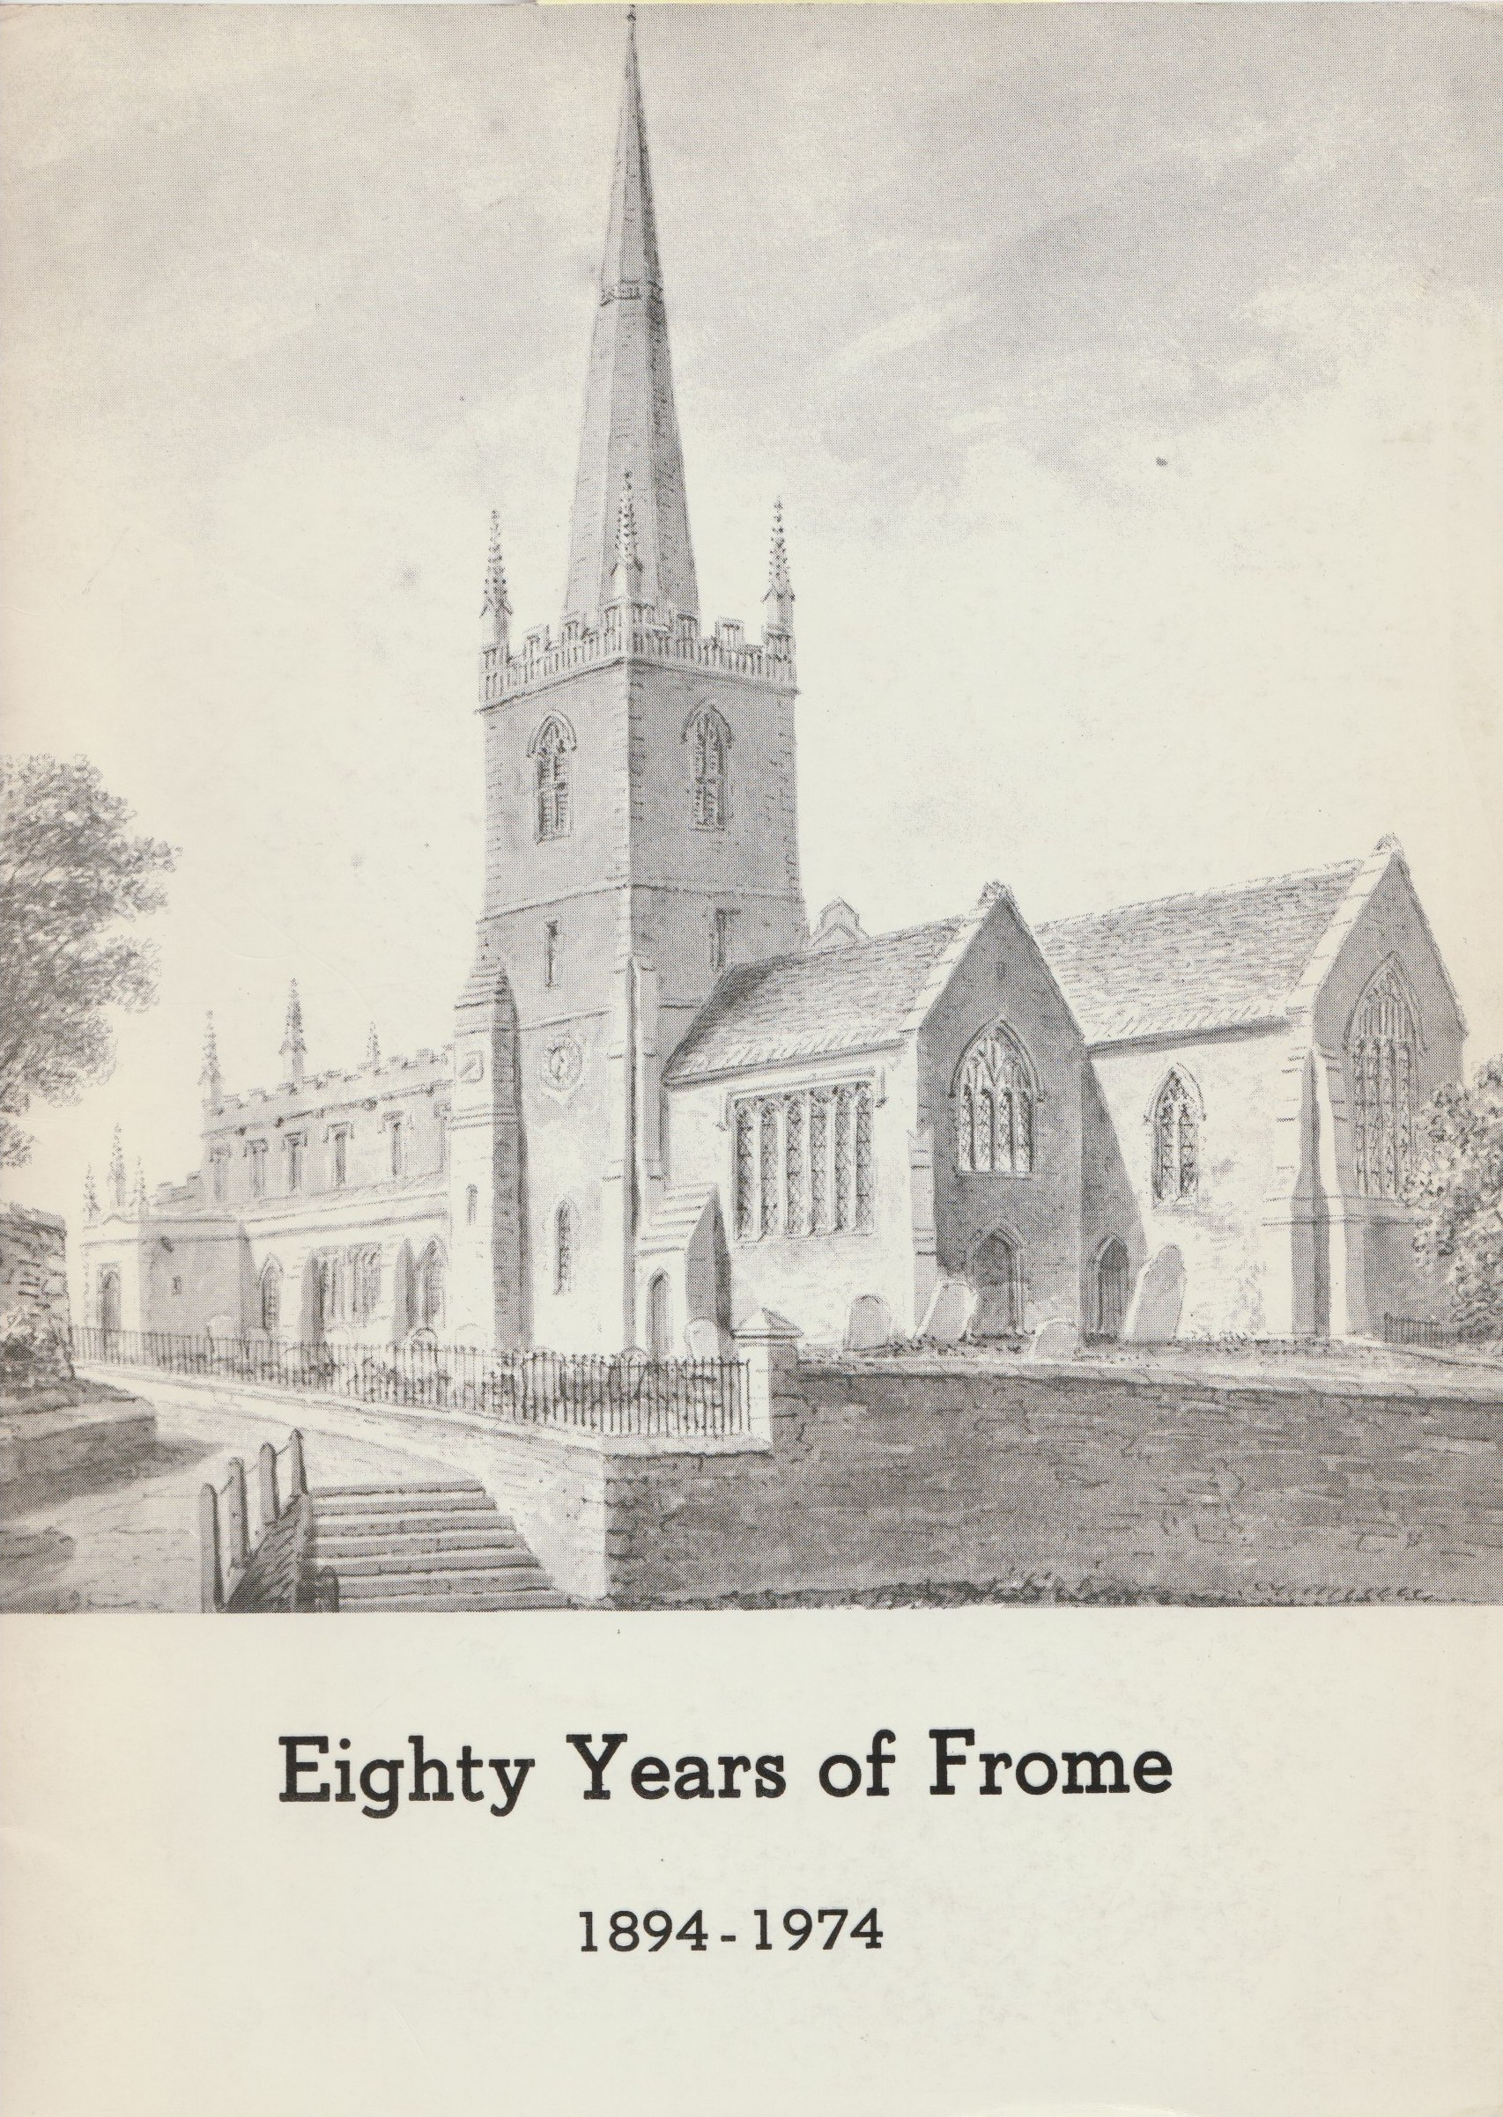

Eighty Years of Frome 1894-1974

by Michael McGarvie (ed) £1.00

A brochure to commemorate the Urban District Council many illustrations and tales of the governing of the town before the council was abolished. Something of a collector's item.

48 pages.

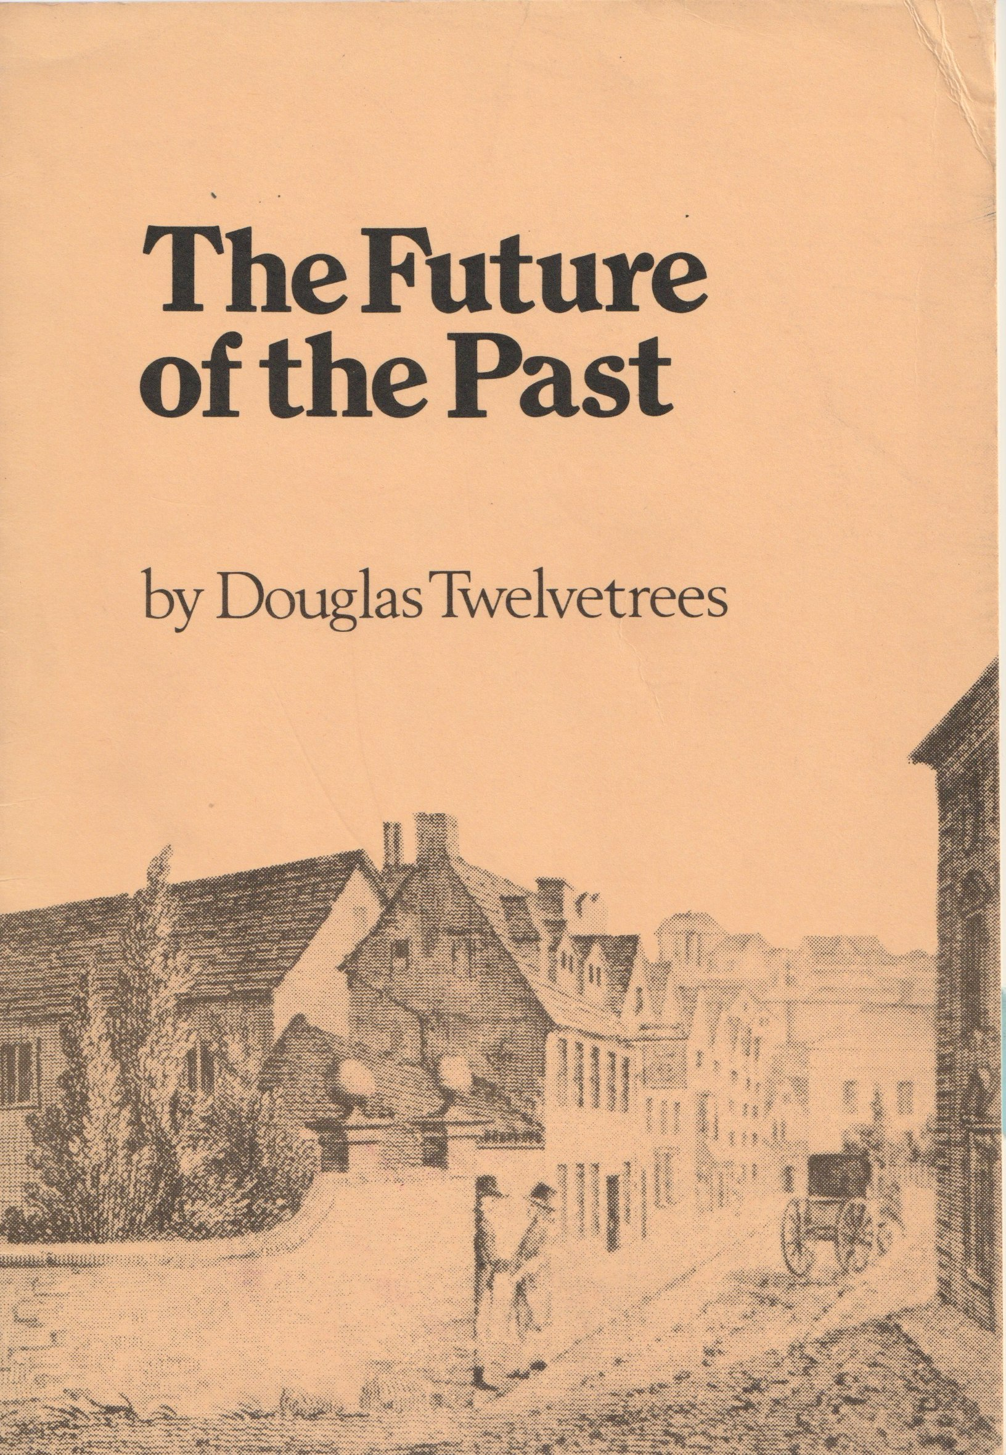
Future of the Past

by Douglas Twelvetrees £1.00
The work of the Frome Society 1958-1973. An excellent and fascinating history of the beginnings of the organised study of the town's history which led to the establishment of the museum and the vibrant society still very active today.

22 pages

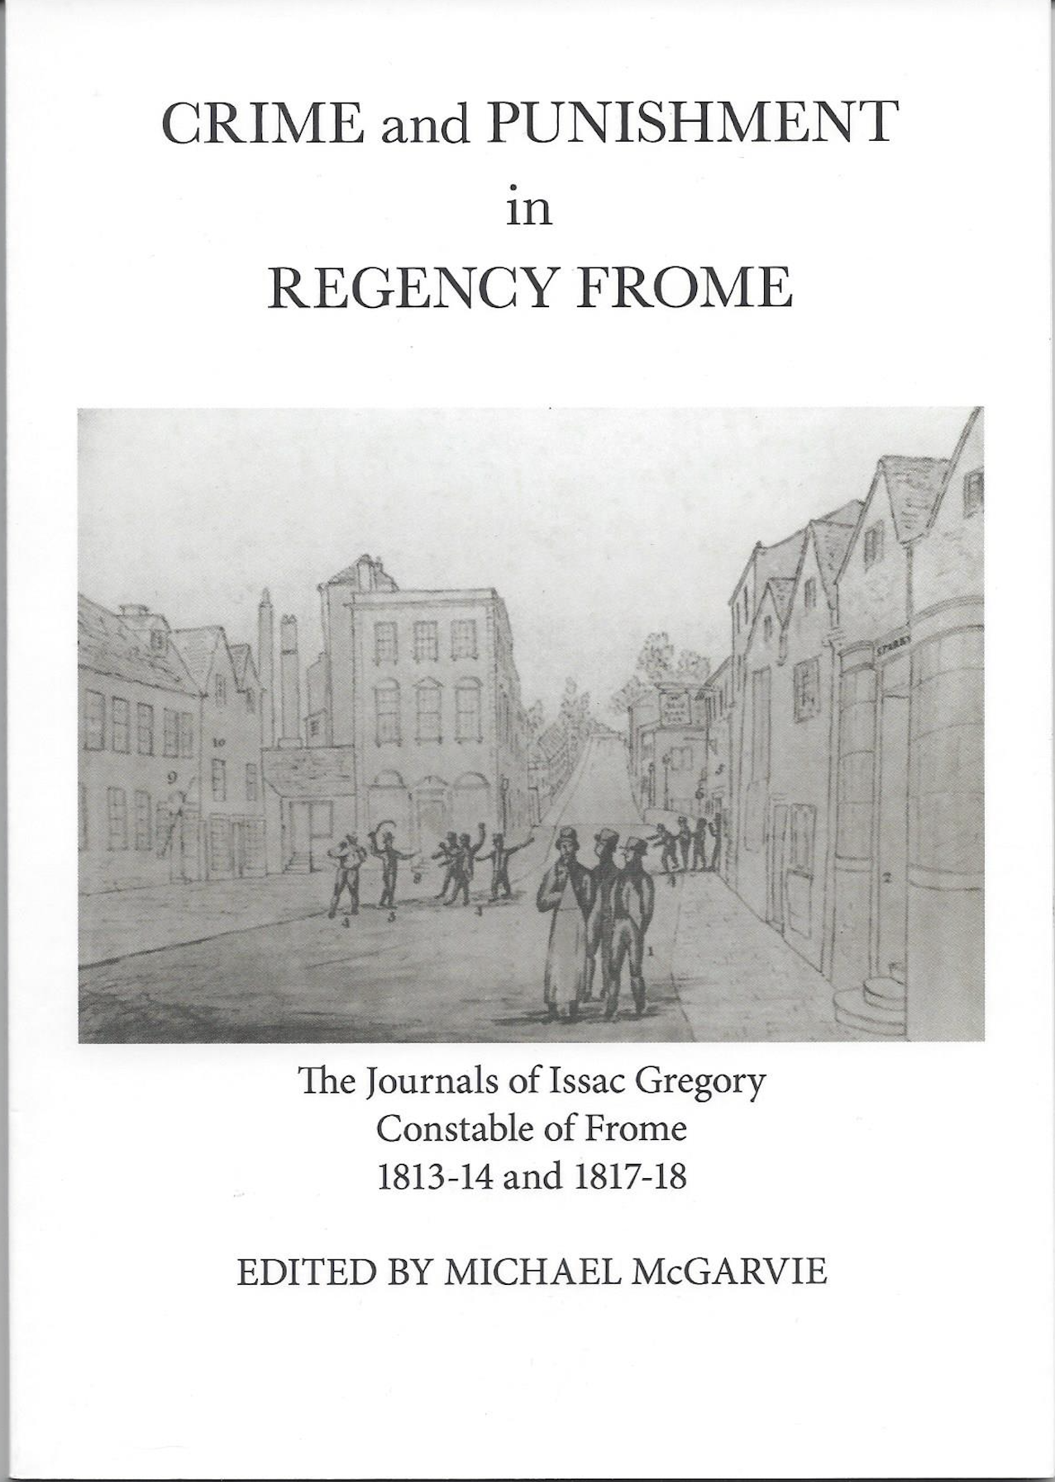
Crime & Punishment in Regency Frome

edited by Michael McGarvie £9.00

The journals of Isaac Gregory, Constable of Frome in 1813-4 and 1817-8 give an original description of how life was lived in the town and the trials and tribulations suffered by the constable in the early part of the 19th century.

63 pages.

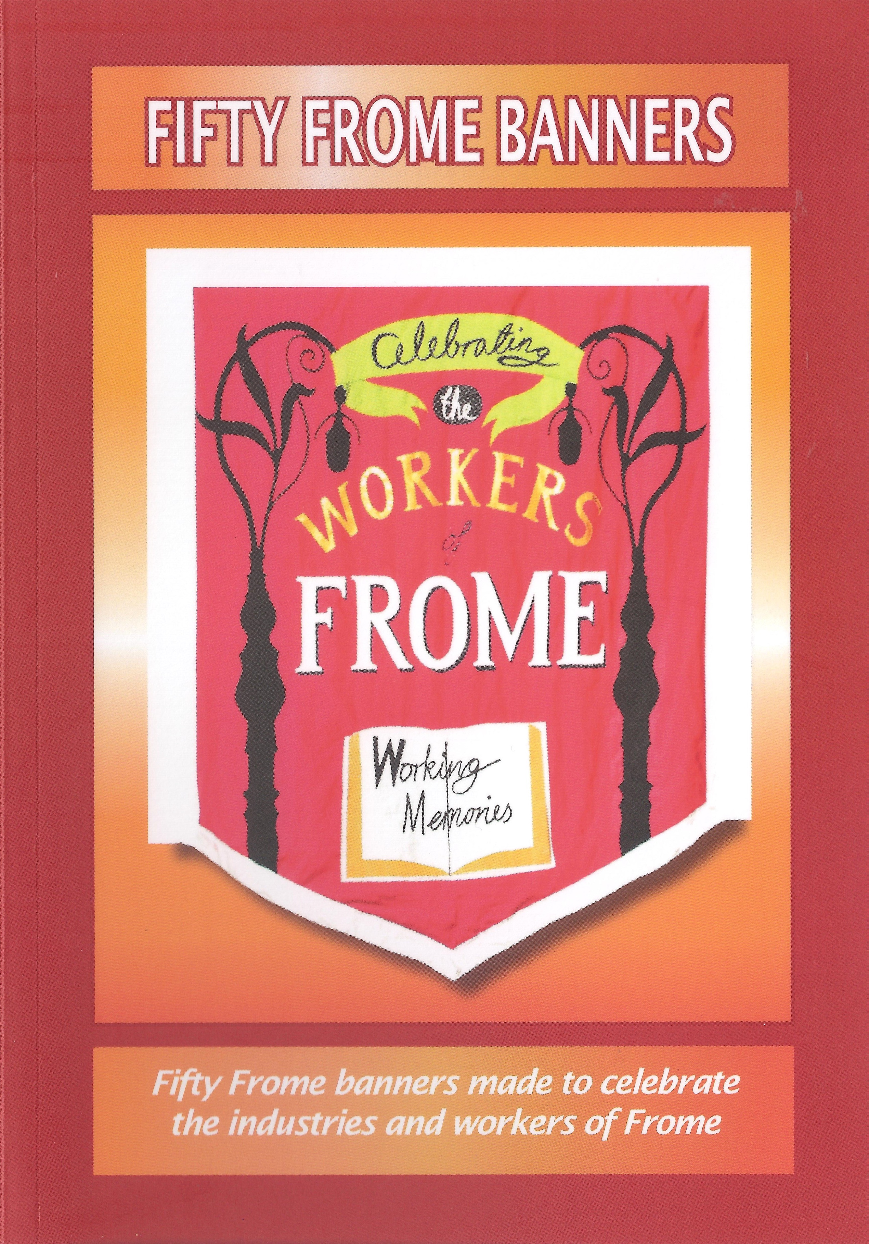

Fifty Frome Banners

by Working Memories £5.00

Fifty Banners made to celebrate the industries and workers of Frome.

48 pages

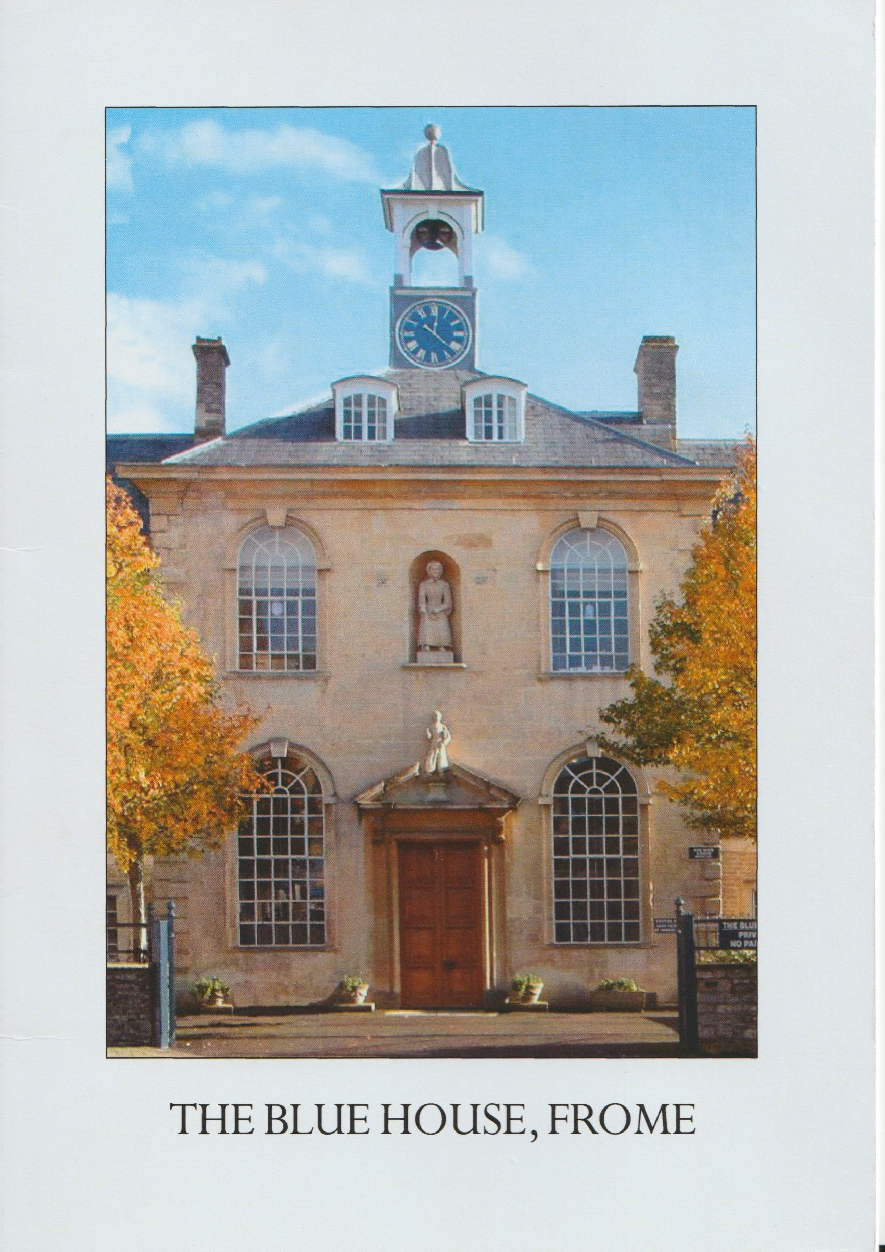
The Blue House

by Michael McGarvie & Hilary Daniel £3.00

One of the town's most iconic buildings dating from the 1720 on the site of an original centuries earlier.
Originally an almshouse and later a 'bluecoat' school it now provides sheltered accommodation for elderly people with their roots in the town.

18 pages

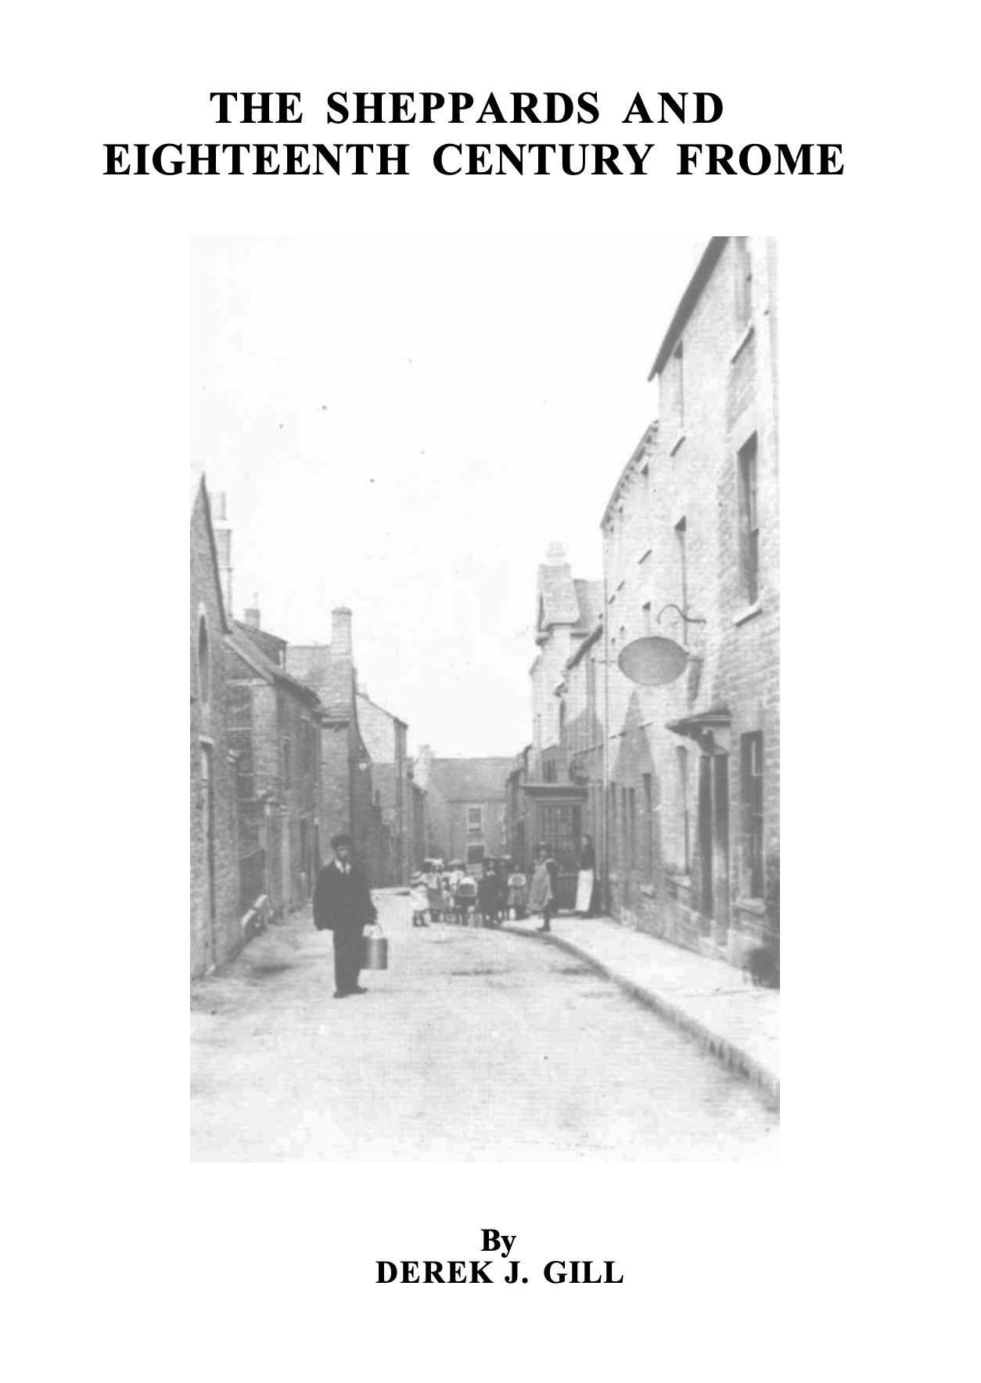

The Sheppards & 18c Frome

by Derek Gill

a brief history of the town's premier clothing manufacturers

Out of print but downloadable in PDF format without charge via Frome Museum website :
www.frome-heritage-museum.org

52 pages 1982

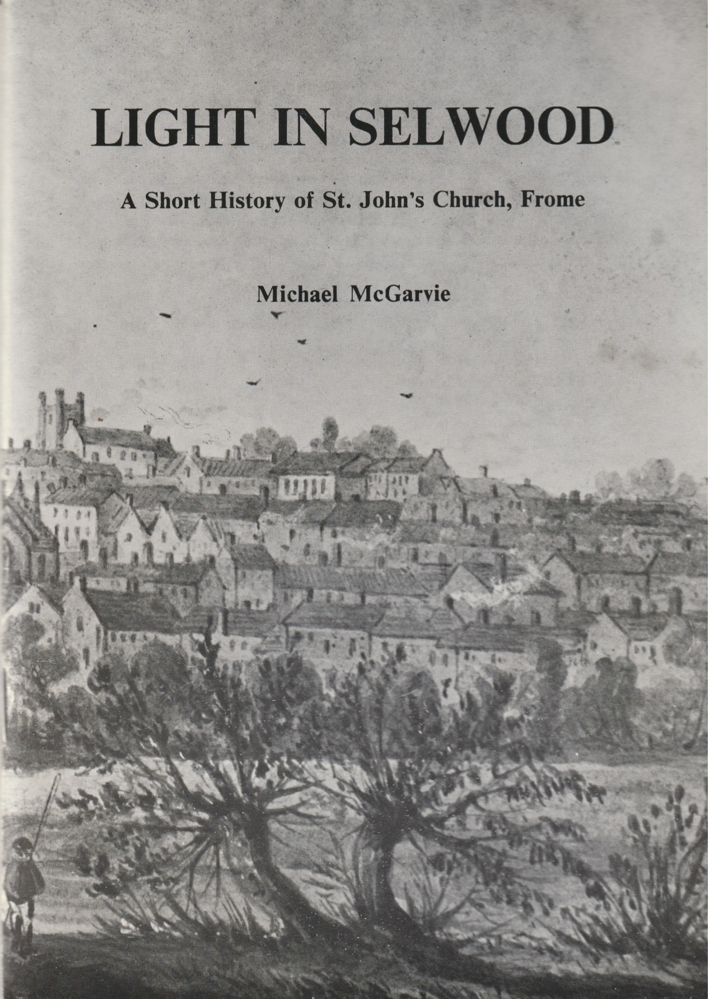

Light in Selwood

by Michael McGarvie

the fascinating story of St. John's Church, Frome from the earliest days.

Out of print but downloadable in PDF format without charge via Frome Museum website :
www.frome-heritage-museum.org

83 pages 1976

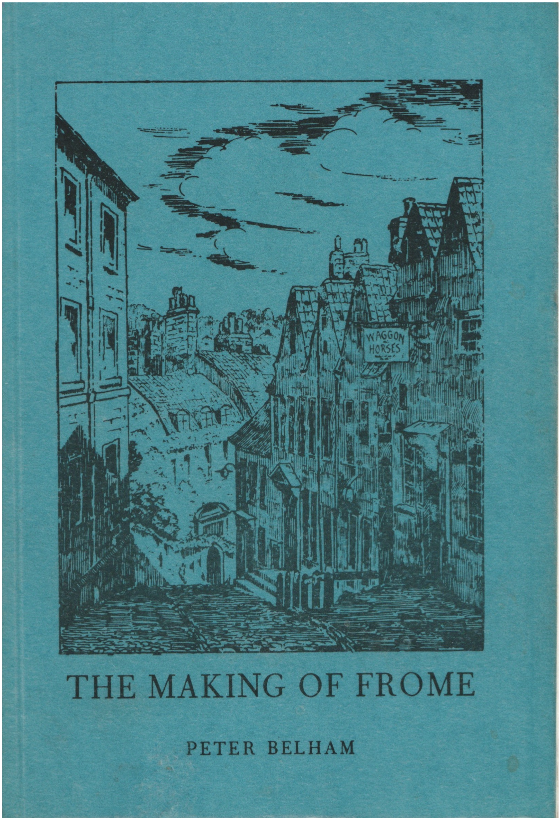

The Making of Frome

by Peter Belham

A detailed and excellent history of the various aspects of the town

2nd edition 1985

Out of print but downloadable in PDF format without charge via Frome Museum website :
www.frome-heritage-museum.org

158 pages 1985

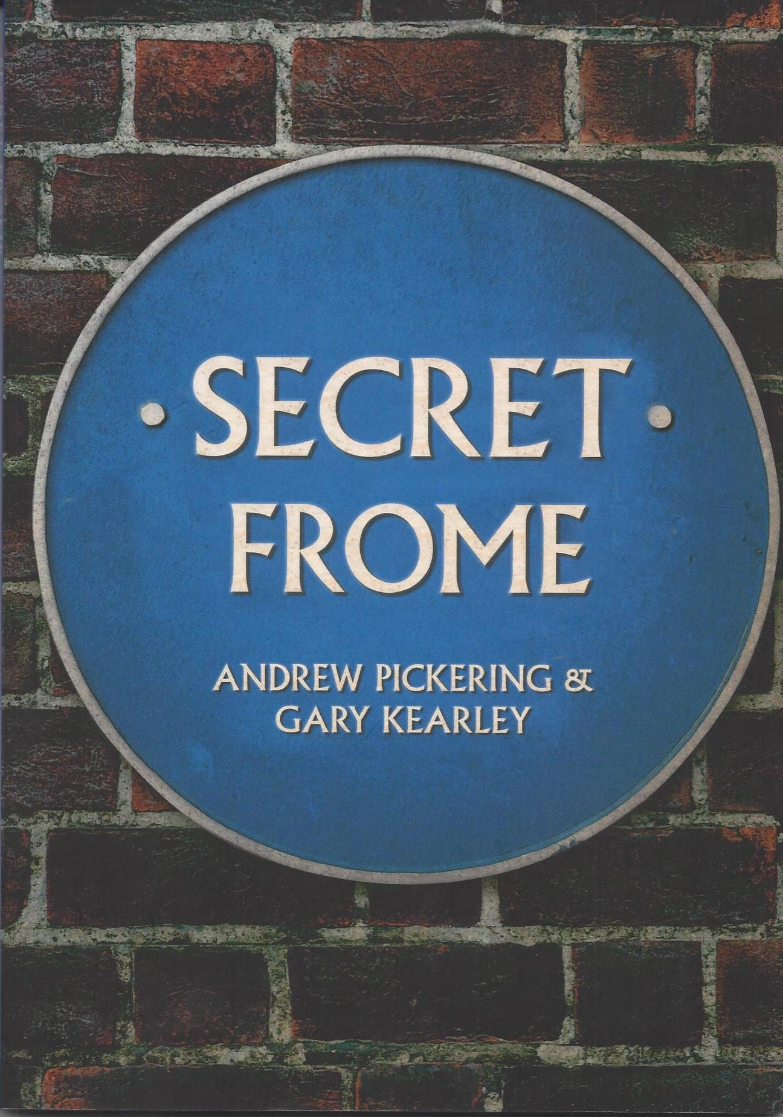

Secret Frome
Andrew Pickering & Gary Kearley £14.99
Ghosts, witches, tunnels and treasure plus many more little-known fascinating facts about our amazing town.
95 pages ISBN 978 1 4456 7266 3

HISTORICAL MAPS OF FROME

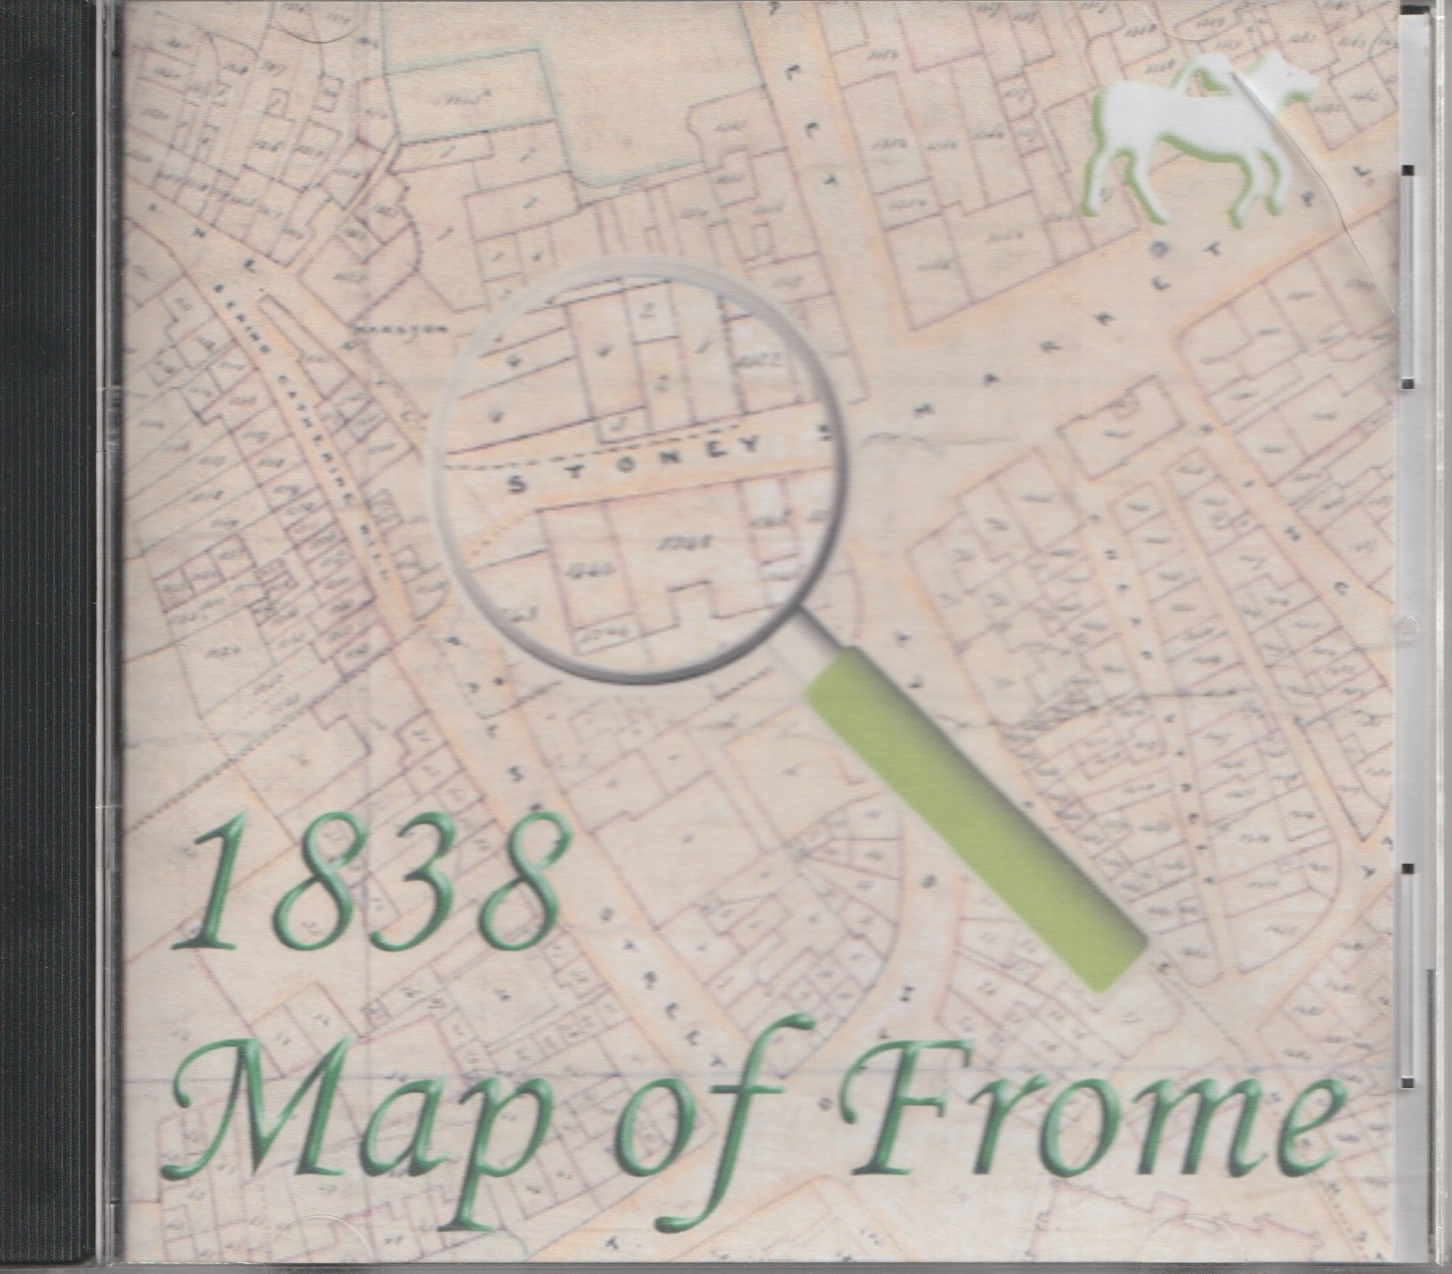
The Borough of Frome Surveyed by Maitland & Dixon January 1838

£10.00
This detailed map gives the plot numbers in the town and can be correlated with St Johns Church rate books for the period 1846 to 1851. It is also possible to work back from 1846 to 1838 where properties have changed hands. The complete map has been split into section with a separate index supplied.
Temporarily unavailable.

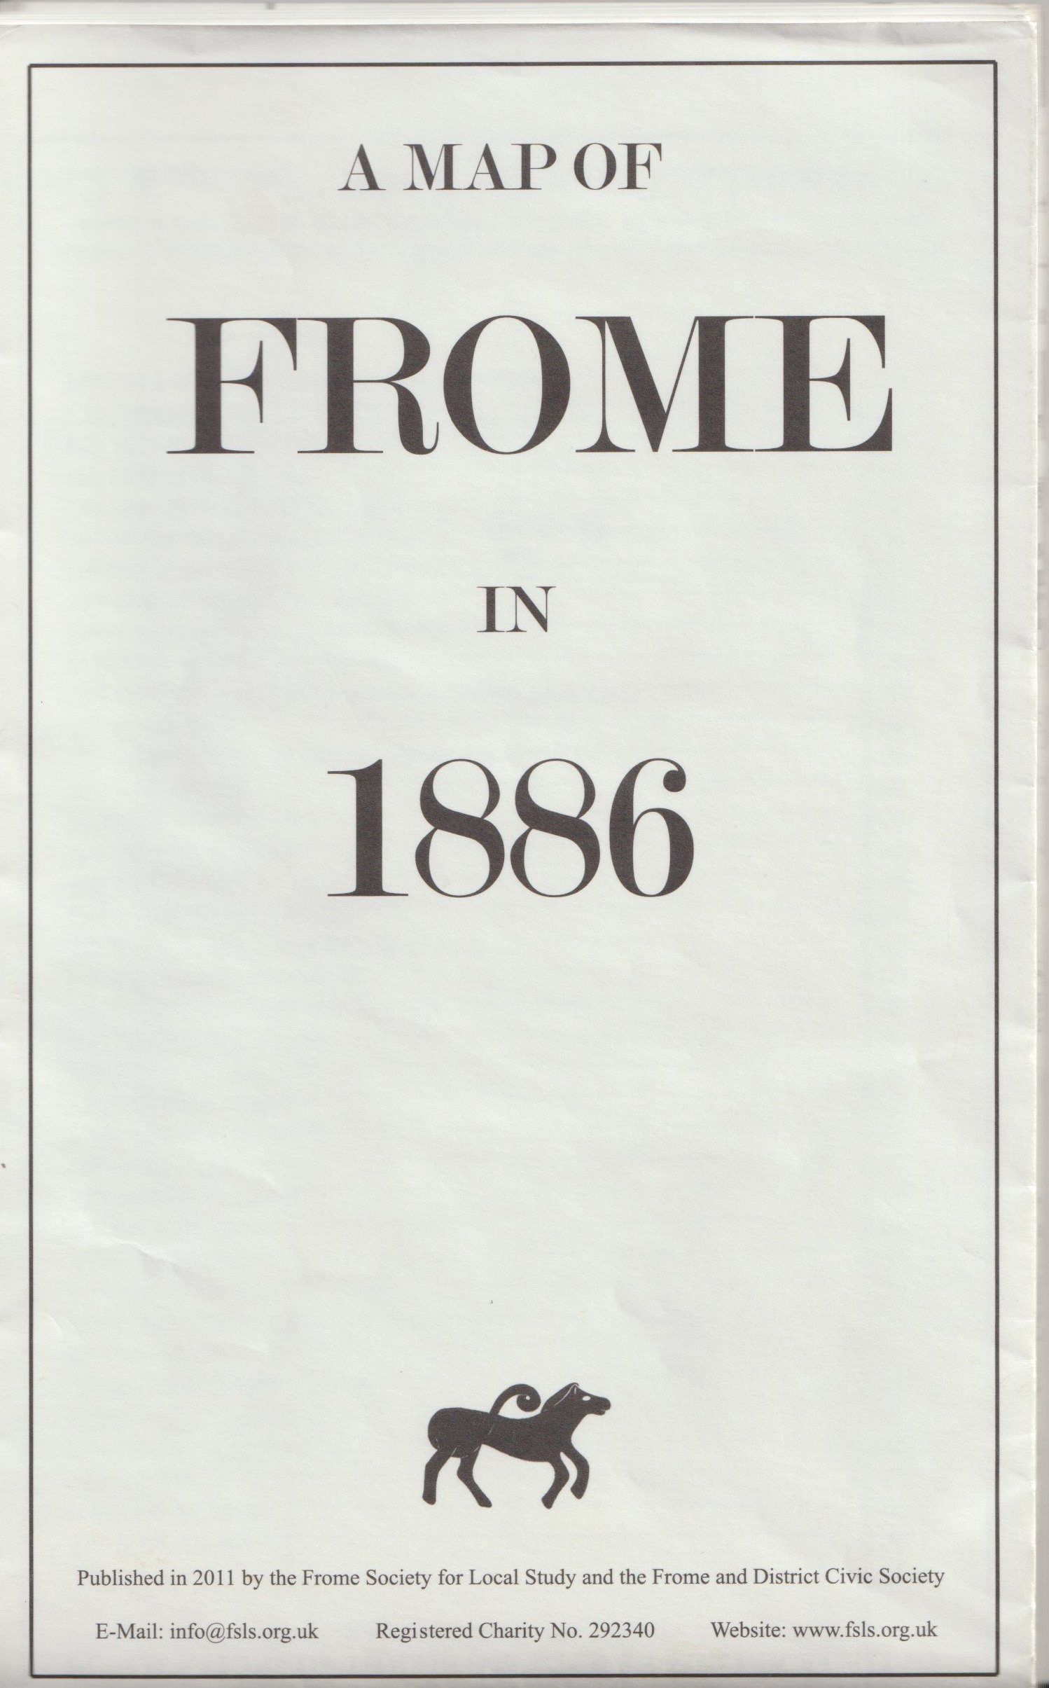

Ordnance Survey map of Central Frome 1886

£10.00

This is to the scale of 1:1000 and covers the nine sheets of central Frome. It is normally supplied folded and opens out to 127×83 cm. It can be supplied flat from the museum if preferred.

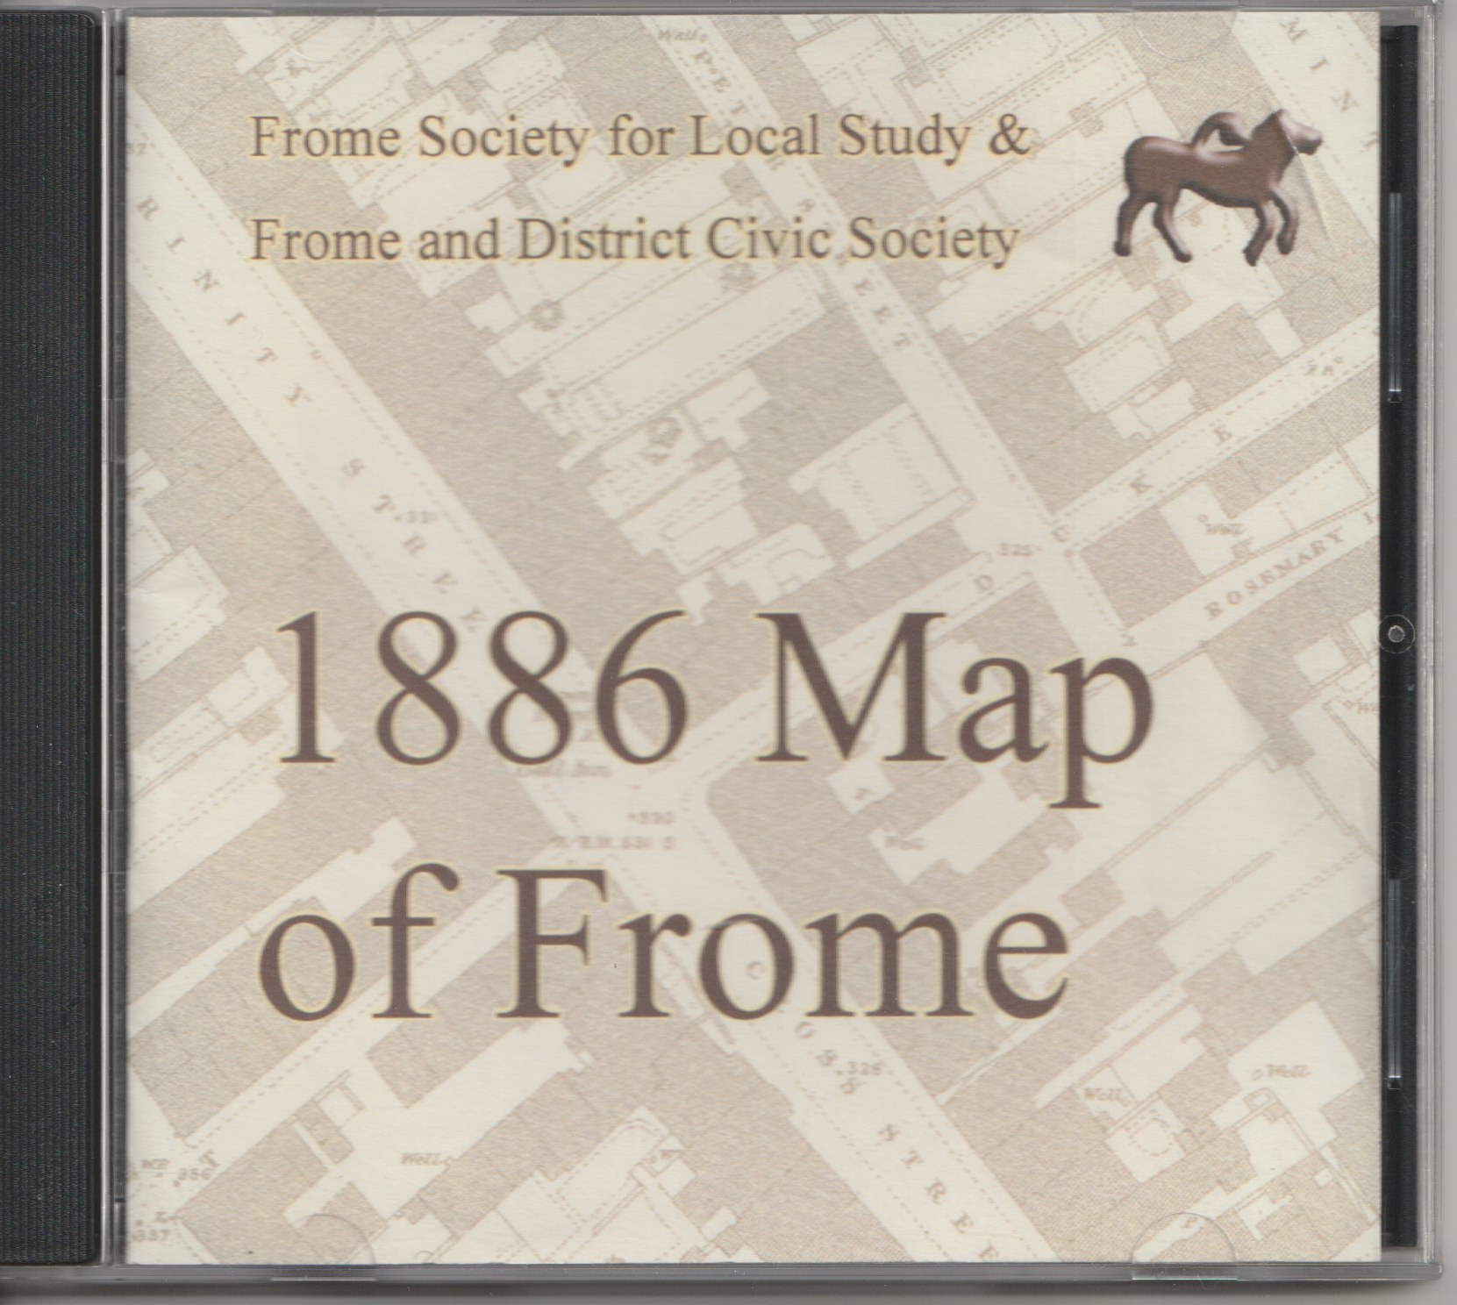
Ordnance Survey map of Central Frome 1886

as above on CD

£10.00

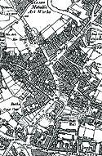
Ordnance Survey map of Frome 1903
This map covers most of Frome and is normally supplied flat but can be folded, if required. The scale is 1:2500 and size is 95.5×82 cm.
Posted as a roll in cardboard tube £10.00

